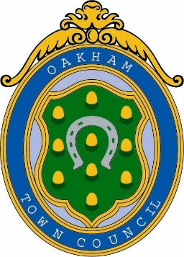
Oakham Town Council
Rol House, Long Row, Oakham, Rutland, LE15 6LN
01572 723627
enquiries@oakhamtowncouncil.gov.uk
www.oakhamtowncouncil.gov.uk

TO: ALL MEMBERS OF THE COMMITTEE

A MEETING OF THE STAFFING COMMITTEE WILL BE HELD ON WEDNESDAY

7th May 2026 AT 3.00 P.M. AT THE OFFICES OF OAKHAM TOWN COUNCIL, ROL HOUSE, LONG ROW, OAKHAM, RUTLAND, LE15 6LN.

Melanie Palmer
Melanie Palmer
Administration Assistant
30th April 2026
NOTICE OF MEETING
Public Notice of the meeting has been given in accordance with schedule 12, Para 10(2) of the Local Government Act 1972.

AGENDA

APOLOGIES AND REASONS FOR ABSENCE

- DECLARATIONS OF INTEREST:
Members are invited to declare disclosable pecuniary interests and other interests in items on the agenda.

3. MATTERS FOR CONSIDERATION IN PRIVATE: To resolve that the press and
public be excluded from the meeting during consideration of the following items on the grounds that they relate to individuals and the financial affairs of
persons. This information is classed as exempt under paragraphs 1, 2 and 3 of Schedule 12A to Section 100A of the Local Government Act 1972.

- MINUTES: To confirm the accuracy of the minutes from the meeting held on Wednesday 29th April 2026.

STAFF MATTERS:

