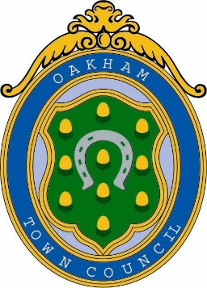
Oakham Town Council
Rol House, Long Row, Oakham, Rutland, LE15 6LN
01572 723627
enquiries@oakhamtowncouncil.gov.uk
www.oakhamtowncouncil.gov.uk

TO: All members of the Town Council
In accordance with the requirements of the Local Government Act 1972, you are hereby summoned to attend a meeting of Town of Culture Committee on Wednesday 18th March 2026 at 1800 hrs. The meeting will be held at the Town Council Offices, Rol House, Long Row, Oakham, LE15 6LN.

Melanie Palmer
Melanie Palmer
Acting Deputy Clerk
12th March 2026
NOTICE OF MEETING
Public Notice of the meeting has been given in accordance with schedule 12, Para 10(2) of the Local Government Act 1972. The Meeting is open to the press and public. Members of the public attending this meeting are advised that it may be filmed and recorded.

AGENDA

APOLOGIES AND REASONS FOR ABSENCE: To receive and approve apologies for absences.

- DECLARATION OF MEMBERS’ INTERESTS AND APPLICATIONS FOR DISPENSATION: Reminder to Members to disclose either a Pecuniary Interest or Other Interest in any item on the agenda. The clerk cannot advise members on this. Members are personally responsible for declaring an interest. Members are respectfully advised to read the Code of Conduct for more information. Councillors are also responsible for ensuring that their Registers of Interests are up to date (within 28 days of any changes)

- DEPUTATIONS FROM MEMBERS OF THE PUBLIC: An opportunity for members of the public to speak in accordance with Standing Orders 1 (d)- 1(i)

- MINUTES: To confirm the accuracy of the minutes from the Full Council meeting held on 18th February 2026.

5. CHAIRMANS REPORT: To receive information

6. COMMUNICATION REVIEW:

7. EXPRESSION OF INTEREST:

8. MATTERS FOR CONSIDERATION IN PRIVATE: To resolve that the press and public be excluded from the meeting during consideration of the following items on the grounds that they relate to individuals and the financial affairs of
persons. This information is classed as exempt under paragraphs 1, 2 and 3 of Schedule 12A to Section 100A of the Local Government Act 1972.

DATE AND TIME OF NEXT MEETING:

NOTES:
a) The meeting is open to the press & public.
b) The Town Council allows a short period of time at meetings of the Full Council when residents can put questions to the council. At other times, the public are not able to take part in the proceedings except at the discretion of the Chairman who may at a convenient time in the transaction of business adjourn the meeting and suspend standing orders to allow any member of the public to address the meeting and ask questions requiring answers of a factual nature.
c) Mobile phones are to be switched to silent during the meeting

