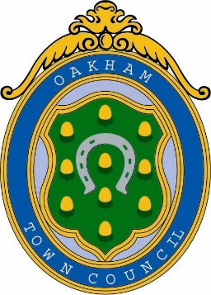
Oakham Town Council
Rol House, Long Row, Oakham, Rutland, LE15 6LN
01572 723627
enquiries@oakhamtowncouncil.gov.uk
www.oakhamtowncouncil.gov.uk

TO: All members of UKToC

Melanie Palmer

Administration Assistant
12th February 2026
NOTICE OF MEETING.

A MEETING OF THE UK TOWN OF CULTURE COMMITTEE WILL BE HELD AT ROL HOUSE ON WEDNESDAY 18TH FEBRUARY 2026 @ 7PM.

AGENDA
- Election of a Chairman
- Inclusion of Other Rutland Settlements / Oakham’s Bid
- Communication Plan, including proposed expenditure
- Expression of Interest (EoI) Form – completion and review of initial allocations:
  - JN – Sections 2.1 and 2.2
  - CC – Section 2.3
  - PA – Sections 1.1, 1.2 and 1.3
- Any Other Business

DATE AND TIME OF NEXT MEETING:

