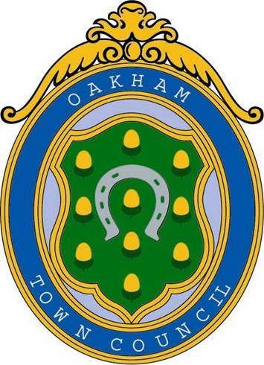

UK TOWN of CULTURE 2028
COMMITTEE (UK ToC)

TERMS OF REFERENCE

Document Control
Version Number | 1
Adopted on | 11-02-2026
Last Reviewed | 11-02-2026
Review Date | 11-02-2027

Town of Culture Committee 2028 – Terms of Reference

1. Purpose
To lead, coordinate, and oversee Oakham Town Council’s participation in the UK Town of Culture programme, including the development, approval, and submission of the Expression of Interest (EOI) and any subsequent stages of the competition.

2. Objectives
- Develop a compelling, evidence-based Expression of Interest for submission to the Department for Culture, Media and Sport (DCMS).
- Engage with local cultural, educational, business, heritage, and community partners to shape the bid.
- Promote Oakham’s cultural identity, heritage, creativity, and community strengths.
- Ensure the bid aligns with the Council’s strategic priorities and delivers community benefit.
- Oversee delivery of any preparatory events, consultations, or cultural mapping activities.

3. Membership
- The Committee shall consist of a minimum of 3 councillors, appointed annually at the Annual Council Meeting or by resolution of Full Council.
- The Committee may invite external advisors (e.g., cultural leaders, educators, heritage experts, business representatives, VIPs) to attend meetings in a non-voting capacity.
- The Chair shall be elected by the Committee at its first meeting each municipal year.

4. Quorum
A quorum shall be three councillors or one-third of the voting membership, whichever is greater.

5. Delegated Authority
Under s.101 of the Local Government Act 1972, Full Council delegates to the Town of Culture Committee the authority to:
- Develop, approve, and submit the Expression of Interest on behalf of Oakham Town Council.
- Make decisions relating to the content, structure, and presentation of the bid.
- Authorise expenditure within the budget allocated by Full Council.
- Commission research, consultation, or specialist support where required.
- Represent the Council in discussions with DCMS, Rutland County Council, cultural partners, and other stakeholders.
The Committee may not:
- Incur expenditure beyond its delegated budget.
- Enter into contracts or commitments binding the Council beyond the scope of the Town of Culture project.
- Exercise any functions reserved to Full Council by law or Standing Orders.

6. Working Groups
- The Committee may establish Working Groups to support specific areas of the project (e.g., Schools Engagement Group, Arts & Culture Group, Business & Hospitality Group, Heritage Group, Youth Voice Group).
- Working Groups may include non-councillors and representatives from external organisations.
- Working Groups are advisory only and have no decision-making powers.
- Each Working Group shall report recommendations to the Committee for consideration.

7. Meetings
- Meetings shall be held as required to meet project deadlines, with agendas published in accordance with the Local Government Act 1972.
- Minutes shall be recorded and reported to Full Council.
- External advisors may be invited to speak to specific agenda items.

8. Reporting and Accountability
- The Committee shall report progress to Full Council at least quarterly, or more frequently if required.
- Any decisions exceeding delegated authority must be referred to Full Council.

9. Review
These Terms of Reference shall be reviewed annually or at the conclusion of the Town of Culture competition, whichever is sooner.

