Meeting Type: Full Council | Agenda Item: 11
Date of Meeting: 12 Nov 2025
OAKHAM TOWN COUNCIL
Report Author: Cllr Paul Ainsley | Purpose: Decision / Discussion / Update
Title: Request to Use and Adapt the Oakham Town Crest
Background:
The Oakham & District Twinning Association seeks permission to use and respectfully adapt the Town Crest for an embroidered pennant, as illustrated below. The design features the Horseshoe in silver wire, gold wire acorns, and a gold ornamental flourish at the top.
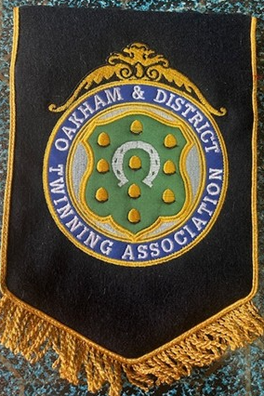
Why It Matters
- Representing Oakham Abroad: The pennant will showcase Oakham’s identity during visits to our twin town, Barmstedt.
- Encouraging Local Involvement: Including the modified Oakham Town crest adds warmth and credibility to community events, helping attract wider participation.
- Preparing for 2027: With the 40th anniversary of the twinning approaching, the crest will help unify and elevate celebratory materials.

What’s Proposed
- Use of the modified crest in non-commercial, community-focused contexts. As well as leaflets, publicity material, correspondence, and other twinning-related communications.
- A minor text change to read Oakham and District Twinning Association, while preserving the original design.
- Council oversight of any adapted versions to ensure respectful use.

Proposal:
- That Council supports the Association’s use of the modified Town Crest in a pennant and in non-commercial, community-focused materials including leaflets, publicity, correspondence, and other twinning-related communications.
- That Council recognises the modified crest as a symbol of civic pride, international friendship, and a positive reflection of Oakham Town Council.
- That Council notes the upcoming 40th anniversary of the twinning in 2027, and supports the modified crest’s use to unify and elevate celebratory materials.

For completion by the office
In Budget ☐ | Spend Authorised ☐ | Budget Header: |  |  | Amount:
Estimates ☐ | Quotes ☐ | Emergency Spend ☐ | Sole supplier ☐ | Specialist ☐ |  | FY:
P.O . ☐ | Invoice Checked ☐ | Reason for spend:
Legal Power: Local Government Act 1972 amend as necessary |  | Contract Finders ☐ | Supplier:

