Meeting Type: Full Council | Agenda Item: 8
Date of Meeting: 08 October 2025
OAKHAM TOWN COUNCIL
Report Author: Cllr Ainsley | Purpose: Decision / Discussion / Update
Title: Appointment of a Town Crier
Background:
Oakham Town Council is seeking to appoint a voluntary Town Crier, an iconic figure who will help strengthen civic pride, enhance council visibility, and celebrate Oakham’s heritage through a blend of ceremonial presence and practical communication.
This role offers a unique opportunity to bring tradition to life while supporting modern engagement. The Town Crier will serve as a welcoming, public-facing ambassador for the council, helping to connect with residents in meaningful and memorable ways.
Key Objectives:
- Champion Oakham’s identity and heritage through a visible, engaging presence.
- Raise awareness of council events, consultations, and services.
- Reach residents who may not engage with digital platforms.
- Add warmth and personality to council communications.
- Record occasional video messages for council social media.
- Engage informally with residents to gather feedback and encourage participation.
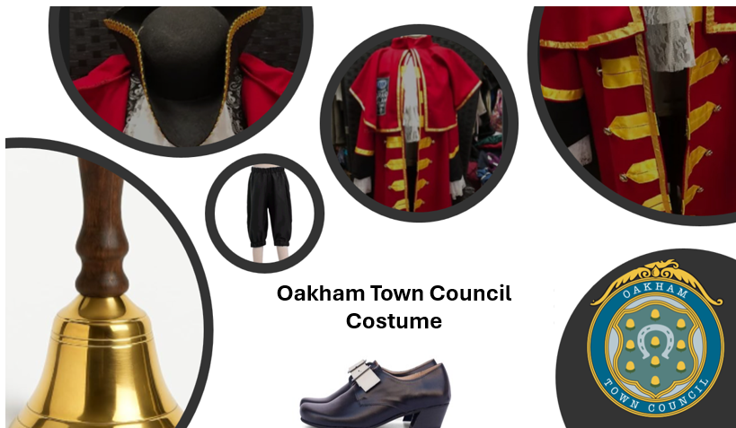
Approximate costing from a specialist supplier is circa £175 for the coat, ruffles and hat. Black britches are £17. Shoes an additional £80, Hand bell £26 and OTC embroidered patch £25

Proposal:
- To recruit aTown Crier to a voluntary post with the objective of enhancing civic engagement, promoting council visibility, and celebrating Oakham’s heritage.
- That Council approves a budget cap for a costume for the Town Crier of £450 charged to the Events/ Promotion/military/banners budget for FY2025
For completion by the office
Budget Header: | Events/ Promotion/military/banners
Proposed Expenditure | £450 | Initial Budget |  | Unbilled Expenditure
Budget Remaining |  | Time Sensitive (Y/N) |  | Expiry Date

