Meeting Type: Full Council | Agenda Item: 13
Date of Meeting: 08 October 2025
OAKHAM TOWN COUNCIL
Report Author: Town Clerk | Purpose: Decision / Discussion / Update
Title: Tree Survey
Trees on Oakham Town Council land require an assessment in October 2025. This includes the following areas:

- Trees in Royce’s Recreational Ground,
- Cutts Close Open Space,
- Elm Close Allotments,
- Willow Crescent Allotments,
- Centenary Field,
- Tennis Courts.

Below are the plans showing the trees that were covered by the previous assessment in orange. Note, blue is a third party tree, green RCC tree, and pink a felled tree.

Royce’s Recreation Ground (Princess Avenue)

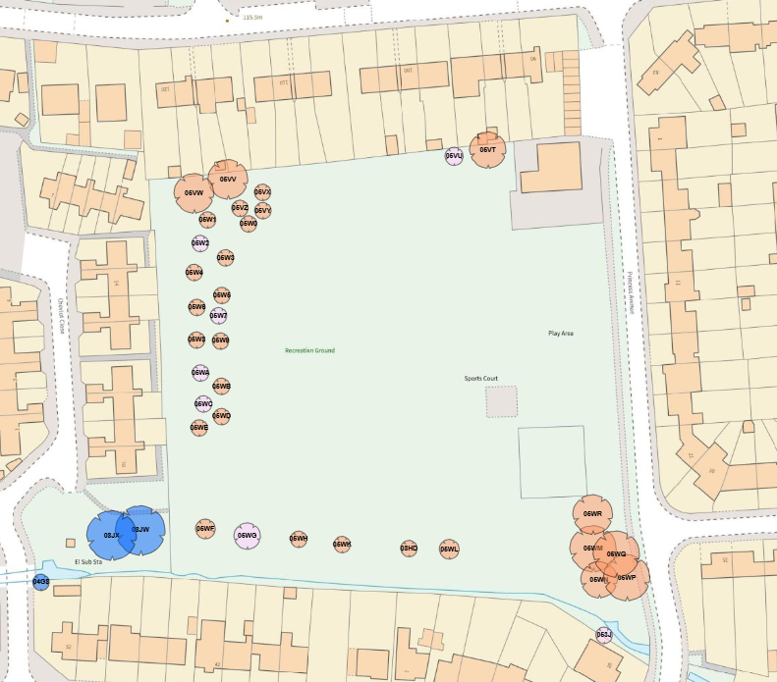

Cutts Close Open Space and Church

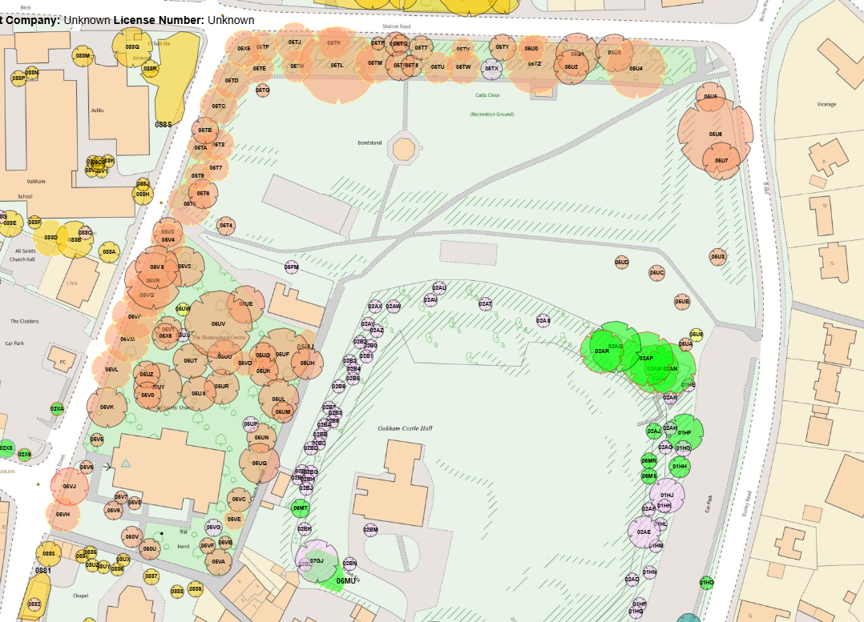

Elm Close Allotments (off Elm Close)

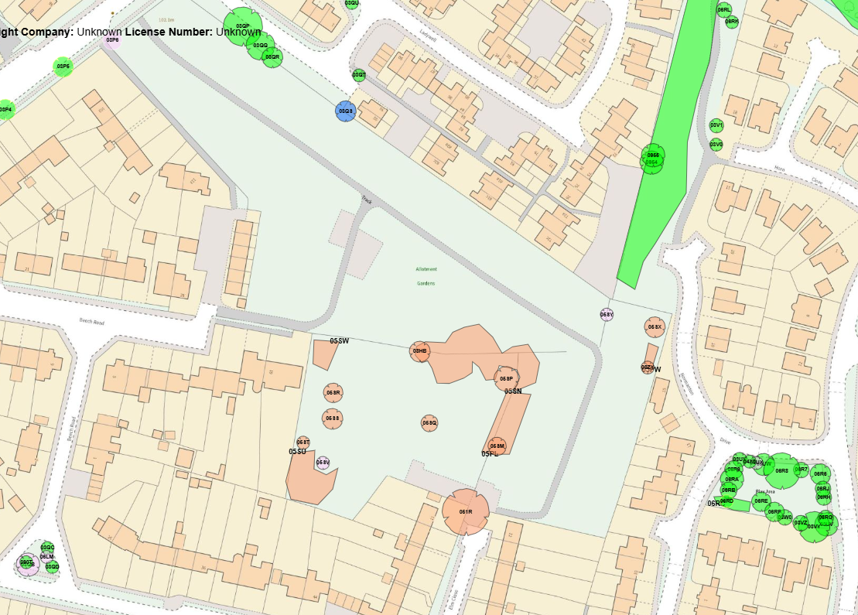

Willow Crescent Allotments (off Willow Crescent)

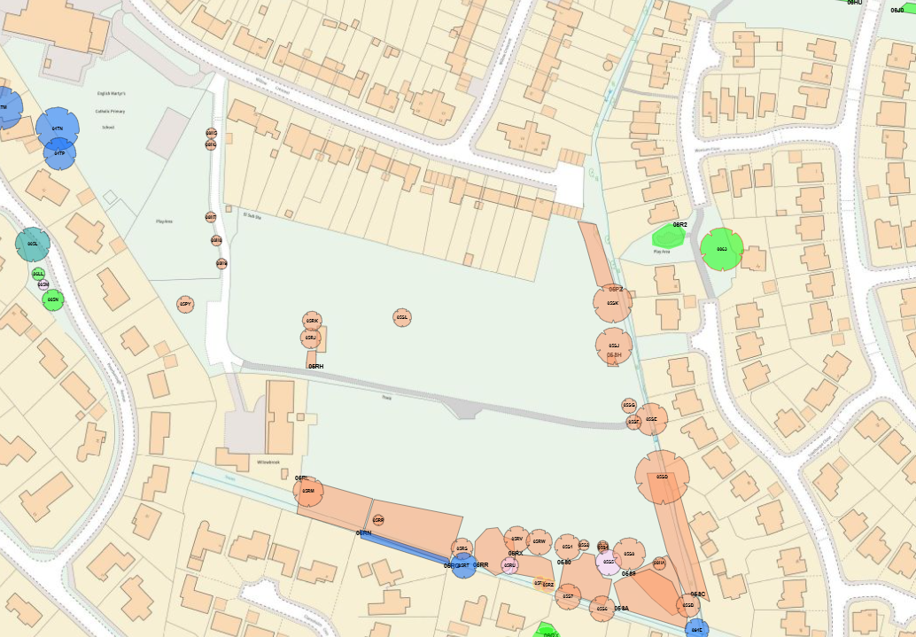

Centenary Field (off Huntsman Drive)

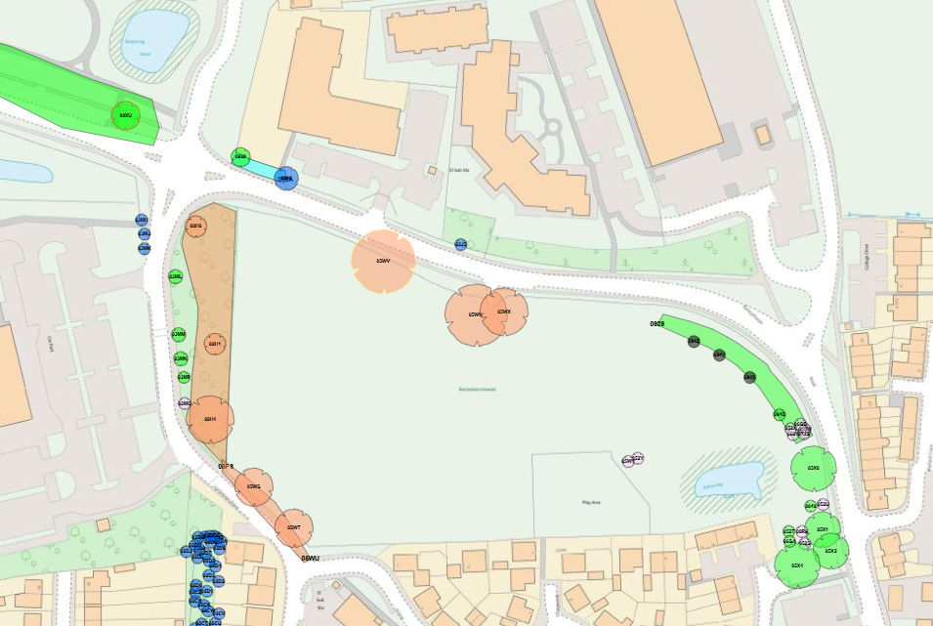

The Tennis Courts (off The Vale)

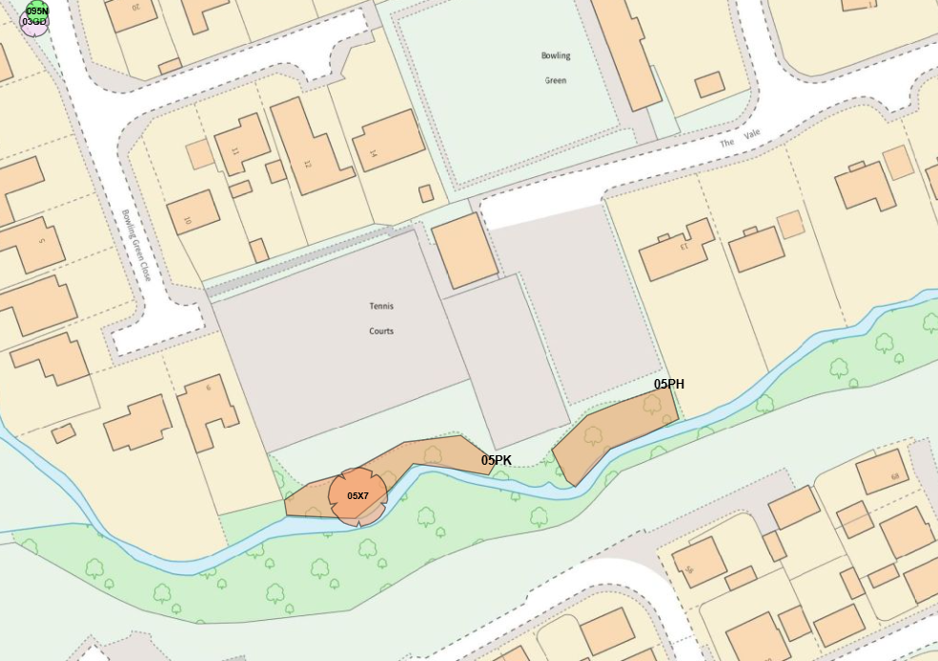

The quote for a ground-based visual assessment for the abovementioned areas will be £1,418.79 (exc. VAT). This will include a report that covers a survey of the trees:

- Condition,
- Age classification,
- Work requirements,
- Priority of work requirements,
- Size,
- Species name,
- Plans showing trees,
- What3Words reference,
- And (where necessary) photographs.

The work recommended will be in line with RCC Tree Maintenance and Assessment Policy, (see attached). It is important to consider this prior to using our services as we will not recommend tree undertaken where a client may want us to (e.g. tree shading a property).

Proposal:
A ground-based visual assessment for the abovementioned areas will be £1,418.79 (exc. VAT), this is within this year’s budget set for Planting and Tree Surgery (9k)

For completion by the office
Budget Header: | Tree Surgery
Proposed Expenditure | £1418 | Initial Budget |  | Unbilled Expenditure
Budget Remaining |  | Time Sensitive (Y/N) |  | Expiry Date

