Meeting Type: Full Council | Agenda Item: 10
Date of Meeting: 08 October 2025
OAKHAM TOWN COUNCIL
Report Author: Cllr Ainsley | Purpose: Decision / Discussion / Update
Title: Adopt a kiosk (phone box) scheme 01572722411
Background:
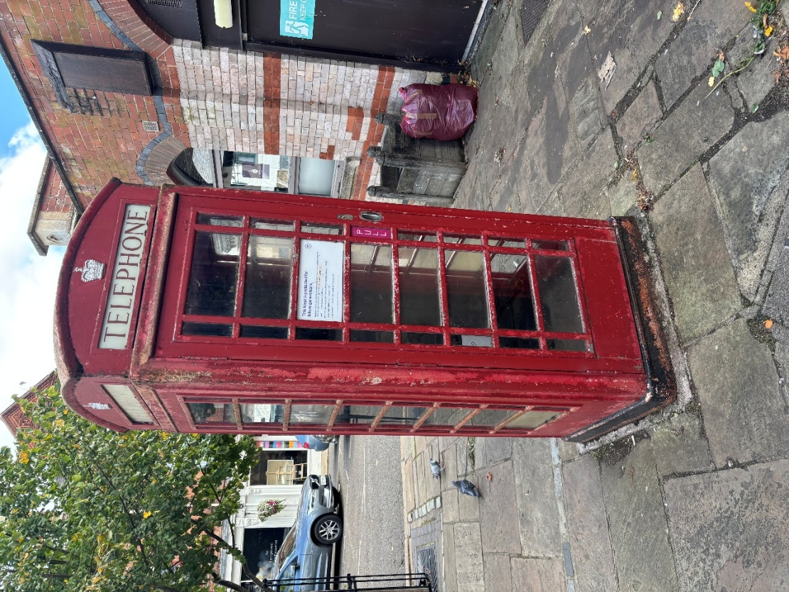
Oakham Town Council have the opportunity to adopt the K6 Listed Kiosk located at the Market Place Oakham, LE15 6DT.


The cost of adoption is £1.
The kiosk is looking jaded and will require sympathetic repainting. A 2.5 litre tin of Telephone Box Kiosk Enamel Paint costs circa £55.
Adopting the kiosk opens up a world of creative and community-minded possibilities. Alternative uses that could be considered (some more practical than others) are:
Civic & Community
- Council info point for notices and QR links
- Public suggestion box or feedback station
- Local history capsule or mini museum
Educational & Cultural
- Little Free Library or poetry booth
- Rotating art or achievement showcase
- Youth engagement via themed displays
Environmental & Wellbeing
- Mental health and support leaflets
- Defibrillator
Practical Enhancements
- Solar-powered phone charging
- Wayfinding maps and walking routes
- Council-branded signage or mascot station
Proposal:
1. That Council resolves to adopt the K6 Listed Kiosk located at the Market Place Oakham, LE15 6DT with a budget drawn from reserves of £500 to cover painting, modification for alternate use and the £1 adoption fee.
2. That the office consults RCC planning and works up a list of 3 suggested alternative uses to bring back to full council at the earliest opportunity.
3. Council approves an expenditure cap of £500 which lies outside the budget for FY2025. The spend is justified by the adoption of a heritage asset and supports community enhancement.

For completion by the office
Budget Header:
Proposed Expenditure |  | Initial Budget |  | Unbilled Expenditure
Budget Remaining |  | Time Sensitive (Y/N) |  | Expiry Date

