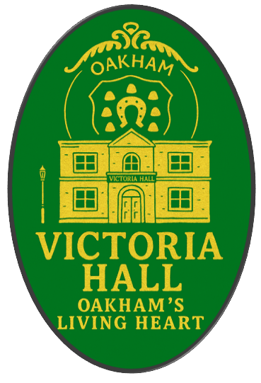

Victoria Hall
Briefing Notes

Table of Contents
Introduction 3
Council Engagement Timeline (2025) 4
Business Rates (NNDR) Briefing 5
Initial Financial Projection (exc VAT) 6

Introduction

Since 1858, Victoria Hall has played a consistent role in Oakham’s civic life. Originally built as the Agricultural Hall, it reflected the practical needs and collaborative spirit of a growing market town. Renamed in 1899 and restored in 2004, the building has adapted over time while retaining its architectural character and community focus.
Today, as a Grade II listed venue, Victoria Hall continues to serve as a flexible space for exhibitions, meetings, performances, and local events. Its central location and distinctive features, like the vaulted ceiling and tall Victorian windows—make it both functional and familiar.
Recent events have reaffirmed its value as a public venue. In June 2024, Victoria Hall hosted a live broadcast of Any Questions? from BBC Radio 4, bringing national political dialogue directly to Rutland residents. It has also welcomed Oakham Pride’s Masquerade Ball, seasonal concerts, and regular arts programming—demonstrating its continued relevance across a wide range of community interests.
Yet despite these successes, the building is now in urgent need of renovation. Years of wear, limited accessibility, and outdated infrastructure are making it increasingly difficult to engage the wider community. The lack of sustained public use has contributed to a financial crisis, and without intervention, there is a real risk that the building may need to be repurposed, potentially losing its civic and cultural role altogether.
The required investment to refurbish Victoria Hall is substantial. Oakham Town Council is currently considering its role in the Hall’s future and must weigh this decision carefully. While it has not yet taken on direct responsibility, the Council recognises the importance of transparent decision-making, community consultation, and long-term stewardship. Any future involvement would need to be grounded in a clear understanding of costs, benefits, and the building’s potential to serve Oakham’s evolving needs.
Victoria Hall has served Oakham for generations. Its future depends on thoughtful leadership, collaborative vision, and a shared commitment to ensuring it remains a space for participation, creativity, and civic life.

.

Council Engagement Timeline (2025)
Purpose: To summarise Oakham Town Council’s formal engagement with Victoria Hall throughout 2025, including key decisions, proposals, and strategic planning milestones.January 2025
8 January – Full Council Meeting
Council agrees to fund a £2,400 building survey, contingent on receiving documentation from Victoria Hall trustees.
Initial debate on the council’s potential role as controlling trustee.
Late January – Trustee Correspondence
Council formally requests governance documentation to support due diligence and clarify future responsibilities.February 2025
12 February – Full Council Meeting
Proposal to relocate council offices to Victoria Hall under a new lease.
Approval of £18,000 boiler replacement, funded via Community Infrastructure Levy (CIL).
Strategic use of Victoria Hall as a civic base discussed.April 2025
9 April – Full Council Meeting
Council confirms intent to relocate to Victoria Hall for a 5-year term, following satisfactory lease terms.
Approval of £6,500 CIL funding to create a new meeting facility by merging Unit 39a with the existing room.
Accessibility upgrades proposed: hearing loop, projection system, and flexible chamber use.
Additional £4,800 from reserves allocated for relocation, redecoration, and IT transfer.
Estimated annual savings of £4,880 from vacating ROL House.
September 2025
Consultant Briefing Development
Council drafts consultant briefs for asset management and strategic planning.
Focus on long-term viability, community use, and governance clarity.

Business Rates (NNDR) Briefing
Context
Oakham Town Council is exploring options to take over Victoria Hall, currently managed by a charitable trust. This insert outlines the potential implications for National Non-Domestic Rates (NNDR), commonly known as business rates.
Key Considerations
- Ownership vs. Trusteeship
If the council becomes the legal owner or rateable occupier, it may be liable for NNDR. If it acts as controlling trustee and the charitable trust remains active, liability may stay with the trust.
- Charitable Relief
Buildings used for charitable purposes may qualify for:
  - 80% mandatory relief
  - Up to 100% relief if discretionary relief is granted by the billing authority
- Use of the Building
Relief depends on how the building is used:
  - Community, charitable, or public-benefit activities may qualify
  - Council offices or commercial use may not
What Needs Clarifying
- Will the charitable trust remain operational and legally distinct?
- What activities will take place in Victoria Hall under council oversight?
- Can the council apply for discretionary relief if it becomes rateable occupier?
Next Steps
- Seek legal advice on the structure of trusteeship and rateable occupation
- Engage with Rutland County Council to confirm eligibility for relief
- Ensure transparency in how the building will be used and maintained

Initial Financial Projection (exc VAT)
This initial financial projection draws on figures provided by the Victoria Hall Treasurer and publicly available data from Oakham Town Council’s accounts. It is intended as a guide to projected expenditure and remains subject to change as circumstances evolve.
Capital investment estimates are based on the Building Survey Report by Gatley / Smithers Purslow, dated 2 July 2025.
Should Oakham Town Council choose to proceed, a fully audited business plan will be required to support any future decision-making.

