Meeting Type: Full Council | Agenda Item: 8
Date of Meeting: 06 August 2025
OAKHAM TOWN COUNCIL
Report Author: Cllr Paul Ainsley | Subject: Discover Oakham
Title: Update regarding our new website – www.discoveroakham.co.uk
Details:

Members will have received the recent promotional communication announcing the launch of our new, free community platform: www.discoveroakham.co.uk.
In addition to this, Nitesh from Creative has provided correspondence affirming his ongoing commitment to supporting and developing this initiative over the long term. This continued engagement underlines the council’s strategic decision to appoint a local specialist with a proven track record.
There have been queries regarding the ownership of the domain names discoveroakham.co.uk and discoveroakham.com. I am pleased to confirm that both domains were proactively secured, as evidenced by the GoDaddy receipt dated Friday 6 September 2024 at 12:28 PM.
Separately, BT has progressed to the planning phase for installation of a Smart Hub outside the B&M store at 2 Westgate Street. While the council requested additional sites, these have proved challenging to secure due to heritage-related constraints.

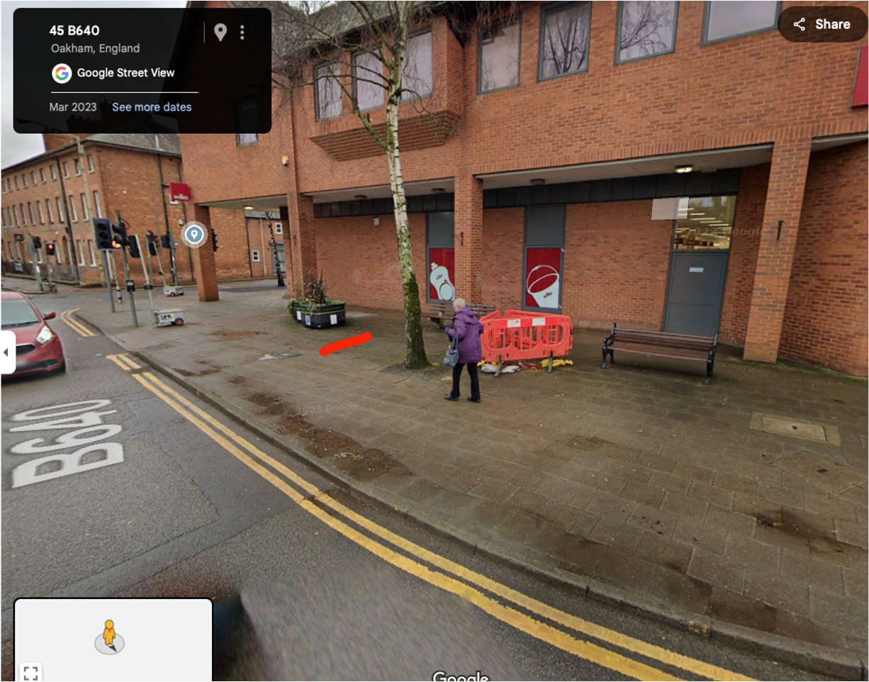

Proposal:
- That Council welcomes the new discoveroakham platform which is a crucial initiative that will strengthen our community ties and the local economy.
- That council agrees to pursue additional locations for the Smart Hubs.

For completion by the office
Budget Header:
Proposed Expenditure |  | Initial Budget |  | Unbilled Expenditure
Budget Remaining |  | Time Sensitive (Y/N) |  | Expiry Date

