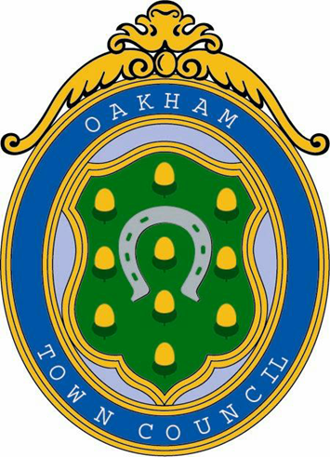

OAKHAM TOWN COUNCIL

FLAG FLYING
POLICY

Document Control
Version Number
Adopted on
Last Reviewed
Review Date

- The following guidance has been compiled in accordance with Government Guidelines. The guidance contained in this document applies to all Oakham Town Council flagpoles, and any future installations at Victoria Hall or elsewhere
- Oakham Town Council Flag
Unless otherwise listed in the approved list of flags and on the date shown, the Oakham Town Council Flag will be flown.
- Flags not included in the approved list
No Organisation's flag may be flown other than those listed in the approved list of flags unless a formal request is received, approved and minuted by a meeting of the full council
- Approved list of flags
10 March: Commonwealth Day | Commonwealth Flag | 
9 April: Wedding Anniversary of HM The King | Union Flag | 
23 April: St George’s Day | Union Flag
6 May: Coronation Day of HM The King | Union Flag
14 June: Official Birthday of HM The King | Union Flag
21 June: Birthday of HRH The Prince of Wales | Union Flag
28 June: Armed Forces Day | Armed Forces Day Flag | 
17 July: Birthday of HM The Queen | Union Flag
3 September: Merchant Navy Day | British Red Ensign | 
8 September: Accession Day of HM The King | Union Flag
9 November: Remembrance Day | Union Flag
14 November: Birthday of HM The King | Union Flag

- Flying at half mast
- The Oakham Town Council Flag shall be flown at half-mast upon the announcement of the death of serving members of Oakham Town Council, serving members of Oakham Town Council staff, and serving members of Rutland County Council. The flag shall remain at half-mast for a maximum period of seven days and shall be lowered again on the day of the funeral.
- The Union Flag shall be flown at half-mast for all state-recognised deaths and shall remain at half-mast until the conclusion of the official period of mourning.
- In the event of the death of a serving Member of Parliament for the area, the Union Flag shall be flown at half-mast in Oakham, the county town of Rutland, until the end of the day of their funeral.

