Meeting Type: Full Council | Agenda Item: 13
Date of Meeting: 12th Feb 2025
OAKHAM TOWN COUNCIL
Report Author: Cllr Paul Ainsley | Subject: Town Website
Title: To develop a new site for Oakham Town
Strategic Aims:
- To improve the quality of life for residents and businesses in Oakham Town
- To create a platform that engages, educates, and increases spending in the town through awareness of retail opportunities and events.
Details:
With reference to 13.1 Project Proposal OTC engages a specialist local company to promote Oakham Town through the medium of an interactive website by exploiting marketing opportunities.

The goal is to create a platform that engages, educates, and increases spending in the town through the awareness of retail opportunities and events.

There are three packages offered. OTC will adopt an incremental approach and go with Package 2 in the first instance. Package 2 includes:

- Brevo is an intelligent tool that captures emails and sends targeted responses or eshots.
- Custom CMS for Business Owners
- 5000 Flyers for business owners to promote the platform

Package 3 can be costed differentially and can be progressed at a future date.
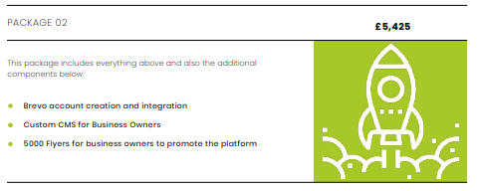
Proposal:
1. That council engages ‘The Rutland WebDesigner’ to proceed with Package 2 at a cost of £5,425, using the UKSPF budget.

For completion by the office
Budget Header: | UKSPF
Proposed Expenditure | £5,425 | Initial Budget |  | Unbilled Expenditure
Budget Remaining |  | Time Sensitive (Y/N) |  | Expiry Date

