Meeting Type: Full Council | Agenda Item: 16
Date of Meeting: 13 November 2024
OAKHAM TOWN COUNCIL
Report Authors: Cllr Ainsley, Cllr Wadsworth |  | Subject: Decoration of empty retail units for the festive period and beyond
Title: Wrapping or painting of empty shop units on Oakham High Street.
Strategic Aims:

1. Ensure that Oakham remains a viable and pleasant environment in which
to live, work and play.
2. Promote the Town as an attractive place to visit and stay.

OTC will work with RCC to brighten up the High Street in time for Christmas and beyond by wrapping or decorating empty shop units on Oakham High Street.

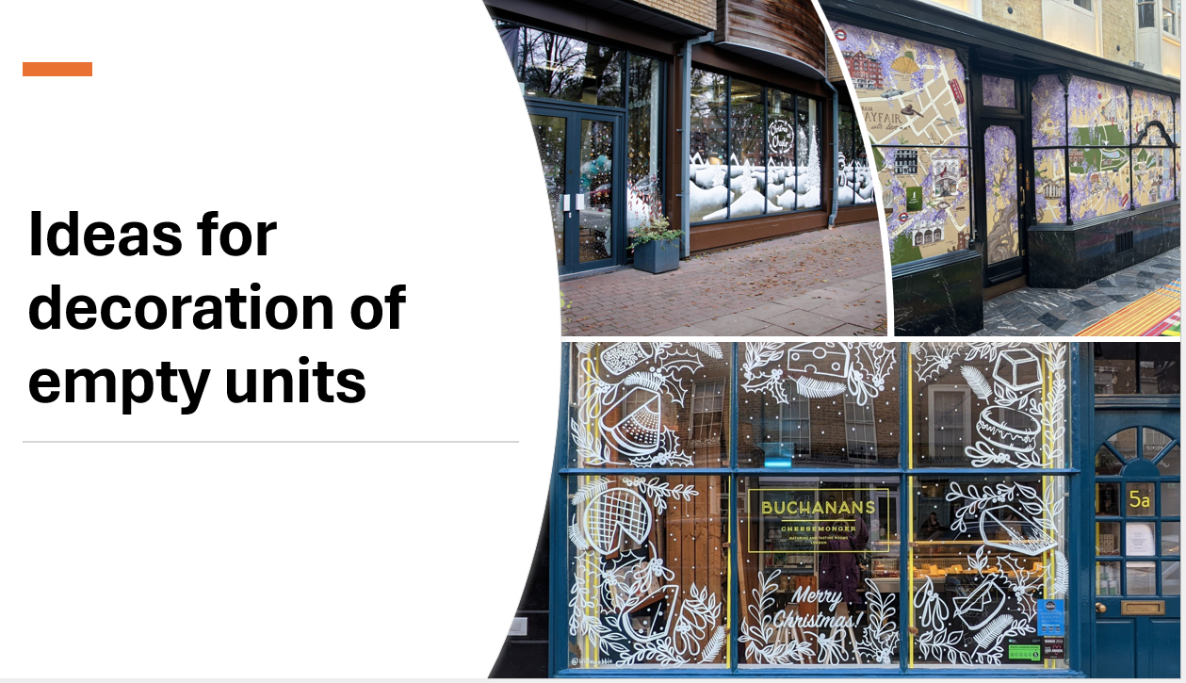

Work and thoughts are at the very early stages but given the very tight timescales approval of a controlled expenditure of £1500 is necessary if the work is to be completed in good time.

It should be noted that it is anticipated that any expenditure will be refunded from the UKSPF.

Volunteers are needed to work with RCC to progress this project
Proposal:
- That council establishes a new working group to progress the wrapping or painting of empty shop units on the High Street.
- That council allocates a maximum budget of £1500

For completion by the office
Budget Header:
Proposed Expenditure |  | Initial Budget |  | Unbilled Expenditure
Budget Remaining |  | Time Sensitive (Y/N) |  | Expiry Date

