**From:** [timandsallyweston@gmail.com](mailto:timandsallyweston@gmail.com) <[timandsallyweston@gmail.com](mailto:timandsallyweston@gmail.com)>  
**Sent:** 27 January 2024 17:58  
**To:** Sally-Anne Wadsworth <[swadsworth@oakhamtowncouncil.gov.uk](mailto:swadsworth@oakhamtowncouncil.gov.uk)>  
**Subject:** Schofield Road

Dear Cllr Wadsworth,

I am in contact to seek guidance regarding a piece of open space in Schofield Road. A site map is attached.

**Background.**

For the last 20 years Bryant Homes latterly Tayor Wimpey have maintained the open spaces on the Kilburn End estate at no cost to residents. The result has been a well maintained and attractive place to live and enjoy. Taylor Wimpey (previously – Bryant Homes) recently auctioned the green spaces on the Schofield Road development to a company based in London called MC Housing. The new owners have now split the areas in to smaller plots and again put these up for auction. Given that the auction is only in a few days, the residents are concerned regarding what potentially may happen next. The legal pack for the sale of the plots is currently unavailable, and it is our concern that this is deliberate so that potential buyers have limited time to research the area which includes ownership and maintenance of a designated green space, flood plain – balancing pond (old Oakham School outdoor swimming pool), stream, gabions and a small section of culverts.

No contact has been made by MC housing to date. MC Housing have elected to auction the large open space facing onto Schofield Road. The auction is to take place in London on the 6th February 2024.

There is no obligation on the current owners or any new owners to maintain this important recreational area and the land could be left untouched and turn to scrubland

**Future Plans**

The site is well used and appreciated by home owners and others living nearby who exercise their dogs, play football and cricket, kite flying etc. It contributes greatly to the local environment and is designated Open Space in the RCC Open Spaces Policy document. As residents we are obviously concerned as to the future of the land, given that any planning permission would be difficult to secure and that the land could be used for fly tipping, go to scrub land or be used for travellers’ caravans etc. Is there a role that Oakham Parish Council can play in this to ensure that the open space is maintained to its current standard. A few of the residents have considered setting up a company to own and maintain the site but to date we have had very little positive response from residents despite leaflet drops etc. Some money has been raised but not enough to secure the site and its maintenance for the next 12 months.

I know all Councils are strapped for cash currently and no doubt OTC is no exception. However, I feel that there is a mid-ground arrangement to be made regarding owning/maintaining with some funding coming from residents and some from the parish council.

If you feel that there is merit in perusing this then please get in touch. Time is of essence as the auction is on the 6th February 2024

I am to meet with a few other residents on Tuesday 30th January at 8.00pm to discuss our options. We would appreciate it if you could reply to this email before then, or even better perhaps join us at our meeting to discuss possibilities for a way forward.

Kind regards,

Mr Timothy Weston

19 Livingstone Close

Oakham

LE15 6FN

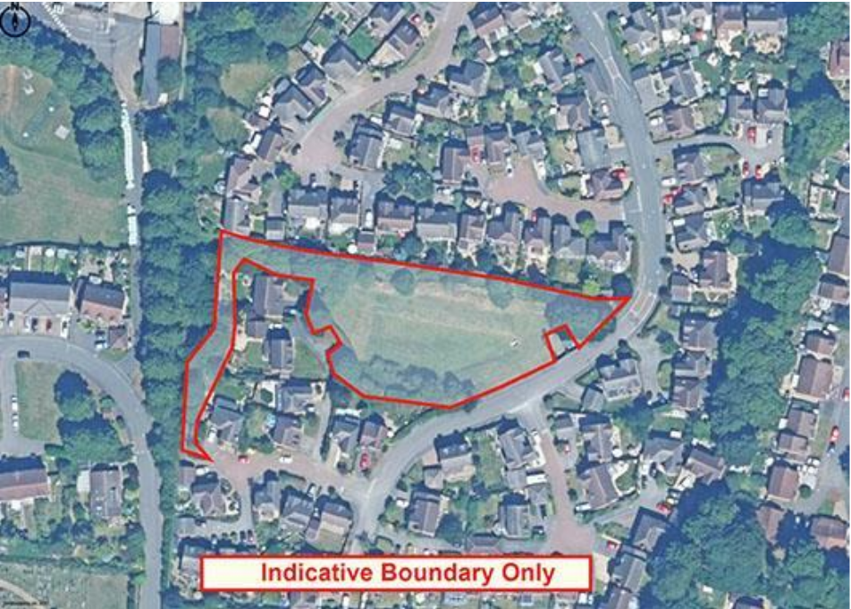

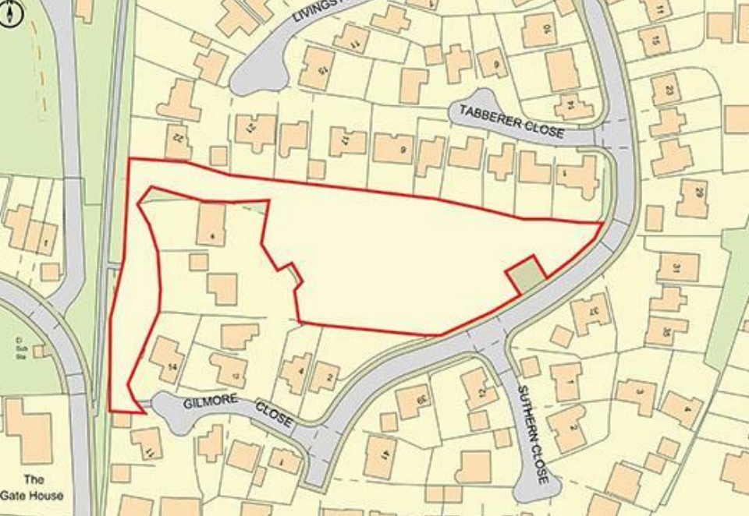

**From:** brianhjolly <[brianhjolly@gmail.com](mailto:brianhjolly@gmail.com)>  
**Sent:** 04 February 2024 16:12  
**To:** Sally-Anne Wadsworth <[swadsworth@oakhamtowncouncil.gov.uk](mailto:swadsworth@oakhamtowncouncil.gov.uk)>  
**Cc:** 'Cllr Hannah Edwards' <[HEdwards@rutland.gov.uk](mailto:HEdwards@rutland.gov.uk)>; 'Tim Weston' <[timandsallyweston@gmail.com](mailto:timandsallyweston@gmail.com)>; 'Andrew Heskin' <[andrew@mooret.co.uk](mailto:andrew@mooret.co.uk)>  
**Subject:** Re: Open Space - Schofield Rd. Oakham

Thank you Sally-Anne for your prompt response. I agree that we are too late as regards the auction but dependent on the outcome we could try to do a deal with either the existing owners or the new ones. Thank you for including the issue part of your meeting on the 14th. I am sure working together that we can retain this important open space

Regards Brian Jolly

Sent from my Galaxy

-------- Original message --------

From: Sally-Anne Wadsworth <[swadsworth@oakhamtowncouncil.gov.uk](mailto:swadsworth@oakhamtowncouncil.gov.uk)>

Date: 04/02/2024 15:56 (GMT+00:00)

To: [brianhjolly@gmail.com](mailto:brianhjolly@gmail.com)

Cc: 'Cllr Hannah Edwards' <[HEdwards@rutland.gov.uk](mailto:HEdwards@rutland.gov.uk)>, 'Tim Weston' <[timandsallyweston@gmail.com](mailto:timandsallyweston@gmail.com)>, 'Andrew Heskin' <[andrew@mooret.co.uk](mailto:andrew@mooret.co.uk)>

Subject: Re: Open Space - Schofield Rd. Oakham

Good  afternoon Tim and Brian

I'm not really sure there is anything we can do regarding the sale of the land.

The next council meeting is on 14th February when I can include your emails and make the council aware of what is happening with this space and any options  we can look at.  If the land is sold on the 6th February, change of use/building will need to come before the planning committee and we can share our views then and advise against any changes.

Once the sale has happened we may be about to discuss with the new owners about their plans and see if there is anything we can do to keep the area as it is.

Unfortunately like you have mentioned  all councils are low on funds so purchasing the land is not an option at present.

Please let me know if the sale goes ahead and if known the new owners.

Regards

Sally-Anne

Sent from [Outlook for Android](https://aka.ms/AAb9ysg)

**From:** [brianhjolly@gmail.com](mailto:brianhjolly@gmail.com) <[brianhjolly@gmail.com](mailto:brianhjolly@gmail.com)>  
**Sent:** Sunday, February 4, 2024 2:26:18 PM  
**To:** Sally-Anne Wadsworth <[swadsworth@oakhamtowncouncil.gov.uk](mailto:swadsworth@oakhamtowncouncil.gov.uk)>  
**Cc:** 'Cllr Hannah Edwards' <[HEdwards@rutland.gov.uk](mailto:HEdwards@rutland.gov.uk)>; 'Tim Weston' <[timandsallyweston@gmail.com](mailto:timandsallyweston@gmail.com)>; 'Andrew Heskin' <[andrew@mooret.co.uk](mailto:andrew@mooret.co.uk)>  
**Subject:** Open Space - Schofield Rd. Oakham

Good afternoon, Councillor Wadsworth.

I hope you will not mind me getting in touch concerning the future of a piece of land, designated ‘Open Space’ off Schofield Road in Oakham. A copy of the site plan is attached on which the area in question is ringed in red.

This land has been maintained by Bryant Homes and latterly by Taylor Wimpey for the last 23 years, all at no cost to the residents and the people of Oakham who benefit from it. The space is used by many for dog exercising, ad hoc football and cricket games, kite flying etc. etc. It plays an important role in the local environment. The space was originally the Oakham School outdoor swimming pool and the dip in the ground is now of benefit to the Environment Agency (EA) as a balancing pond for when the Brook, which runs along the northern boundary overflows. The EA now monitor the water levels on a 24/7 basis using a fixed camera and they maintain the outflow and Brook banks on a regular basis. In November last year Taylor Wimpey auctioned off all the ‘open spaces’ which formed the original Kilburn Road Estate. The pieces of land, including the one illustrated on the attachment were purchased by MC Housing a ‘trade on’ developer based in North London. They now having done their researches realise that the large open space on Schofield Rd. is unlikely to result in any tangible benefit, being zoned Open Space in the Rutland County Council’s Policy documents as well as being labelled a Flood Risk site by the EA. MC Housing have elected to auction on this site only and the Auction is scheduled for Tuesday 6th February, via the offices of Barnard Marcus in London. A number of residents on the estate are obviously very concerned about the future of this land as there is no incentive to carry out any ongoing maintenance, with the possible outcome of scrub land, fly tipping and use by travellers. Properties on the estate have been contacted about this and have pledged to date a sum just under £7,000. to buy and maintain this open space. We do not however have enough funds to purchase and maintain the site for the first 12 months.

Hence this email to enquire if the Town Council could ‘come to the table’ to agree an arrangement where by the residents could contribute to it’s purchase and the Town Council take on the responsibility of ownership and maintenance.

You will note that the Auction is imminent and it may be sold or not. Either way we could jointly contact either the current owners or future owners to see if they would agree to sell/long lease this piece of amenity land to the Town Council, in return to relieving them of ongoing maintenance costs.

I and others on the Estate would be happy to meet with you and your colleagues if you feel this would help in order to reach a satisfactory outcome regarding this important piece of land.

Kind regards

Brian Jolly

01572 756075

07979 756542

1 Tabberer Close, Oakham