Report No : 12 | Council  Date of Meeting: 14th February 2024

OAKHAM TOWN COUNCIL

Report Author:  Phil Wildbore | Title: Tree Champion – Barleythorpe Road councillor
Subject: Grounds Maintenance Contract – Past, Imminent and Future
Applicable Strategies:
- To protect and enhance amenities in Oakham Town.
- To preserve and enhance the rural, built, and natural environments of Oakham Town.
- To enable residents to be involved in the life of Oakham Town and its future development.

Executive Summary
Members have approved the advertising for bidders for the 2024-27 grounds maintenance contract, which contains our specifications. These are being sent to bidders who have expressed interest.
Our specification has not had a meaningful review. There is an urgent need to rectify short-term impacts of continuing with our current specification.
There are medium-term needs, to initiate both a review of this contract and to evaluate all our open spaces.
Our 5 open spaces lack any management plans or improvement plans. The single ‘one size fits all’ contract has scope for interventions by officers by adopting a method specification – whereby we tell experienced contractors what to do – whereas more progressive councils have moved to an output-based type of specification which puts the onus on them to achieve what we want. This avoids public dissatisfaction.

PROPOSALS
- To endorse that the frequency of mowing of Royce’s recreation ground and Centenary Field are harmonised to 30 per year;
(This is the most credible and realistic action that can be taken at this stage and should have been done before contracts were sent out).

- If proposal 1 is carried, require those contractors supplied with copies of our current Bill of Quantities be immediately advised of this addendum;

- To support the requirement for individual management plans to be progressed for the separate amenity/recreational areas which will allow for various aspects of Grounds maintenance for the 2024 season to be reviewed;

- To agree the validity of the ‘Supervisor Role’ and the review of how could work in practice from April 2024. Require the supervising officer to report monthly on where interventions have been made, the instructions given, and the outcomes delivered?

- To agree establishing a Grounds Maintenance Champion.
Logical fit is within remit of existing Tree Champion as a clear relationship exists.

Discussions
On 10 January 2024 council approved the advertising for tenderers for 3 years of grounds maintenance (GM). This is to commence with a new contractor from 1 April 2024. A budget is set in the precept of £40,000 per year. This is potentially our council’s largest external contractual commitment.
The tender advert advised further information was available from officers. This became apparent as removing the prices from the 2020-2023 contract and continuing with the previous specification.
Unfortunately, there appears to have been no review of the adequacy of this specification; despite the agreed commitment by the Town Council to progress such a review. The contract details clearly confirm it is far too complicated and overstated with inappropriate requirements which are not practical and do not happen in practice. There is an onerous emphasis and expectation on the ‘supervising officer’ role within the Town Council, in particular, is ridiculous and embarrassing. The overall costing for the GM Contract is obviously massively understated and allocation of specific costs to specific activities incorrect and very misleading. There are numerous examples of anomalies and erroneous details which makes the contract specification somewhat meaningless. One example being that all grass for us is cut to 15mm to 20mm. The opportunity for changes in cut height during the seasons is one of the supervisory variables listed in the contract. In the current contract the supervising officer is the Town Clerk.

Finished quality is principally delivered in two ways. First, there are varying frequencies of mowing/strimming. Second, the numerous provisions for the supervising officer to make interventions listed in the contract, for example:
- at 3.7(b) clods of over cut grass can either be evenly distributed over the grassed area, or if the cuttings prove difficult to distribute, they shall be collected and removed from site at the Supervising Officer’s direction at no additional cost;
- at 3.9 ‘Cylinder Mowing Without Removal of Grass Cuttings’, undertaken using a pedestrian or ride on type cylinder mower or a combination of both types but capable of producing a minimum of 36 cuts per metre (33 cuts per yard). The finished height of cut will normally be no greater than 20mm and no less than 15mm. Any variations to the finished height will be specified by the Supervising Officer;
- at 3.11 The height of the final cut of the season will be specified by the Supervising Officer;
- at 3.13 The grass cutting season will commence and finish according to the instructions of the Supervising Officer in accordance with the Summer growing season. The Contractor should make provision for the occasional Winter Gang Mowing cuts which will be specified by the Supervising Officer when required. The Supervising Officer will give at least three days advance notice and will only specify such cuts when weather and ground conditions are like those experienced during the summer cutting season.
There are 179 times in the current specification where ‘supervising officer’ arises.

- All points to a radical change being needed. Open spaces need a champion.

Public and councillor complaints on the final grass cutting quality implies that either the first, second or both parts of the current quality assurance are ineffective.

With the tender process underway there needs to be minimal but timely corrections to ensure an effective contract is in place. This impacts costs and budgets.
Cutts Close frequently met an acceptable standard in 2023. This is most likely due to the highest frequency of cuts 32 times per year. Likewise, at Royce’s Recreation ground, good at 30 cuts. Centenary Field at 16 cuts per year is the known area of discontent with reoccurring complaints by the users of the field and the public, regarding poor/variable quality including excessive grass cuttings frequently left after the 15-20mm cuts. These issues have adversely affected the functionality of the field and there is clearly no justification for the disparity in cutting frequency between Centenary Field and Royce’s Recreation ground as both provide similar recreational functions.
These 3 areas all use the same specification of gang mowing. All Saints churchyard and Willow Crescent use pedestrian mowing.

- There needs to be consistency between Royce’s Recreation ground and Centenary Field as both perform similar recreational usage. The proposal is that the 2024 cutting frequency is harmonised at 30 cuts per year at each asset. This simple process should clearly have been actioned before tendering contracts were dispatched.

Centenary Field also houses our largest trim trail, the circumference of which encloses 40% of the mown area. Safety inspections and potential claims may implicate any poor mowing.

We have a tree champion. There is a logical link that this GM role ought to encompass our open spaces in which most of our trees are contained. There must be an administration role for officers, but councillors/champions must take a greater responsibility in our public image. This would essentially mean practical aspects of any contract should have the input of the ground’s maintenance champion. This would re-distribute those 100+ variables with the Town Clerk.

Future strategy
Council has an obsolete management plan for Cutts Close on our web site Download the Cutts Close Management Plan. This has obvious shortfalls like not including biodiversity/environmental and aspects of grounds maintenance etc. (This management plan identified the cut frequency at 30/yr; so clearly ‘something changed between 2016 and 2020.) However, this does provide a framework for the new and separate management plans for the five assets listed at https://oakhamtowncouncil.gov.uk/parks-open-spaces/.

The past intent of OTC is plain in having a management plan for Cutts Close which is still on our website. Is it practical in 2024, as it came out of the aspirational heyday of seeking Green Flag status. In 2023 there was reluctance to plant a bush owing to archaeological costs.

Management Plans are only of value when they are SMART – Specific, Measurable, Attainable, Relevant and Timely.

All three layers of plans demand that ward councillors have an appreciation for their ward and council leadership gives strategic oversight.
- To not let individual management plans drag, these are to be completed for submission in 2024 to a full council meeting.
- Any new open spaces should have agreed management plans in place within 4 months of acquisition.
- Updated and agreed open space management plans should be in place before each round of GM tenders.

The management plans should aim to be a vehicle to get the right GM in the right asset, at minimal costs whilst ensuring consistent finished qualities.
Some areas where the grounds maintenance champion and officers should engage are:

- Validating the effectiveness of the 2024 grounds maintenance contract. Rather than us having a restrictive contract we need to listen to each of the contractor’s capabilities, and this can only be achieved through close liaison. They have expertise across many councils.
- To establish whether published literature on ‘mowing standards’ are appropriate for each management plan. (https://www.rhs.org.uk/lawns/how-to-mow-a-lawn = only remove one third of grass growth, https://www.lawnexperts.co.uk/recommendedcutheights.html
  - = different cut grass heights for different grass types,
  - https://www.pitchcare.com/blogs/news/facts-about-mowing = different grass heights dependent on function;)
- Establish whether a ‘single grass cutting height’ is appropriate or should be integrated into a grass cutting regime which considers the specific requirements of areas categorised by their functionality;
- To evaluate suitable areas of re-wilding, biodiversity, and green corridors to promote insects and wildlife. This has been central to the works in Centenary Field over 11 months;
- To review the interventions made by the supervising officer in the 2020-2023 contract period;
- To provide a pre-emptive input into the next grounds maintenance tender.(For example some innovative town councils have adopted broad approaches to securing one provider for: Grass Cutting, Hedge Cutting, Path Sweeping, Dog & general Waste Bin Emptying, Flower Bed maintenance, Playground safety checks and minor repairs, Tree inspection reports and minor tree works https://www.christchurch-tc.gov.uk/2023/04/grounds-maintenance-invitation-to-tender/.
- Benchmark what Oakham achieves against other councils, their tenders, and contractors;
- Take account of climate change. Wetter and warmer gives rise to grass growing;
- Define if there is a better style of contract that is less onerous on officers;
- To help identify and further evaluate the effectiveness of current in-house grounds maintenance and how this activity can be improved/extended to raise the efficiency and quality of overall grounds maintenance activities;
- To consider the training and management needed to deliver grounds maintenance.

Costs
The imminent tender prices will identify future costs.
Applying historic and comparative costings to the key item of harmonisation:
- The accepted bid value in our current contract identifies the cost of mowing Centenary Field is £59.07 per visit.
  - The 16 cuts/year cost £945.12/year.
  - Raising the frequency to 30 cuts per year would cost £1,772.10.
An increase of £823/year.
This looks a trivial increase, yet with all the quality interventions at the discretion of the supervising officer poor performance could have been resolved in 2023.
It does also serve to illustrate how misleading the Biffa cost base is. They tendered for ‘land off Barleythorpe Road’ not ‘Centenary Field’ – an error that has been carried through into the new contract.

- In January 2024 Council voted to retain the windowflowers floral contract for 2023-24.
At Centenary Field this uniquely has 11 railings troughs at a cost of £2,524.50.
  - So a comparative cost being Centenary Field could be mowed 42 times at this price of transient flower displays.
This somewhat flippant comparison illustrates our Council’s priorities?

Unfortunately the nature of the current, and potentially future ‘grounds maintenance’ contract as it is drafted by us, is that it is a ‘waste contract with the inclusion of mowing’. This is clearly illustrated in the following table which shows how the percentage costs of current activities fall across all open spaces. There is no current reason to suspect that the percentage of the cost base will change.

Activity | % of current contract costs
Powered Gang Mowing – Cutts, Royce’s, Centenary | 24
Pedestrian Mowing – All Saints, Willow | 7
Pedestrian Strimming | 15
Grass Edge strimming | 3
Litter Picking | 23
Emptying Litter/Dog Bins | 12
Sweeping | 9
Hard Area Sweeps | 4
Hedge Maintenance | 1

Hence less than a third of the expense is on mowing. This illustrates the point made earlier how misleading and inappropriate the current contract appears to be.

The present, and future contract depends on bidders visiting our open spaces. We don’t have defined maps and stated areas.
I estimated from Google Earth we have about 69,000 square metres of mowing/strimming.

Our current contract – combining all forms of mowing and strimming – gave a price per visit of £539.94 (£191.51 at All Saints, £156.31 at Cutts, £90.09 at Royce’s, £66.83 at Centenary and £35.20 at Willow).

Appendices

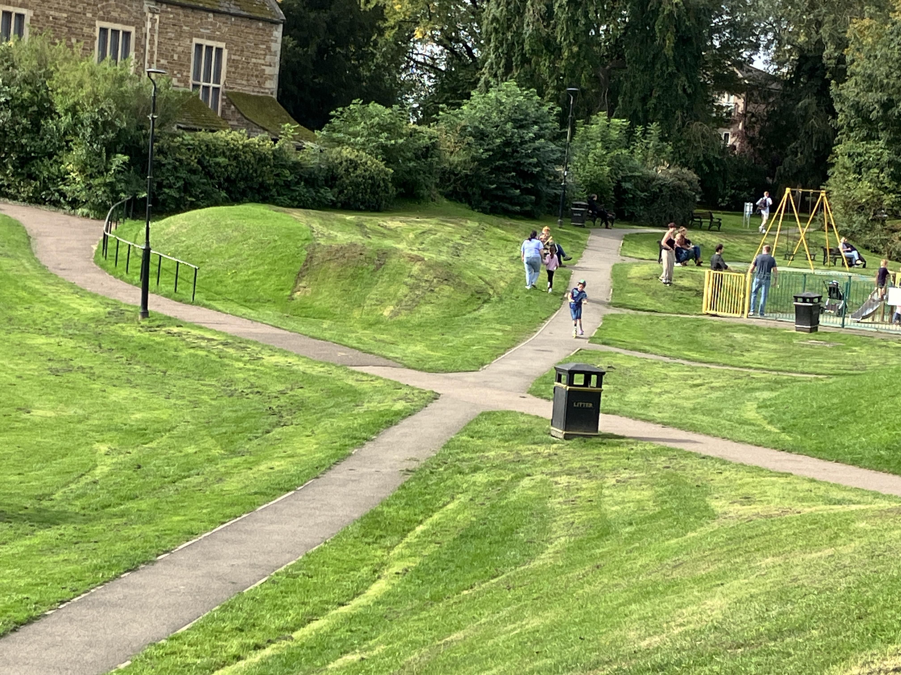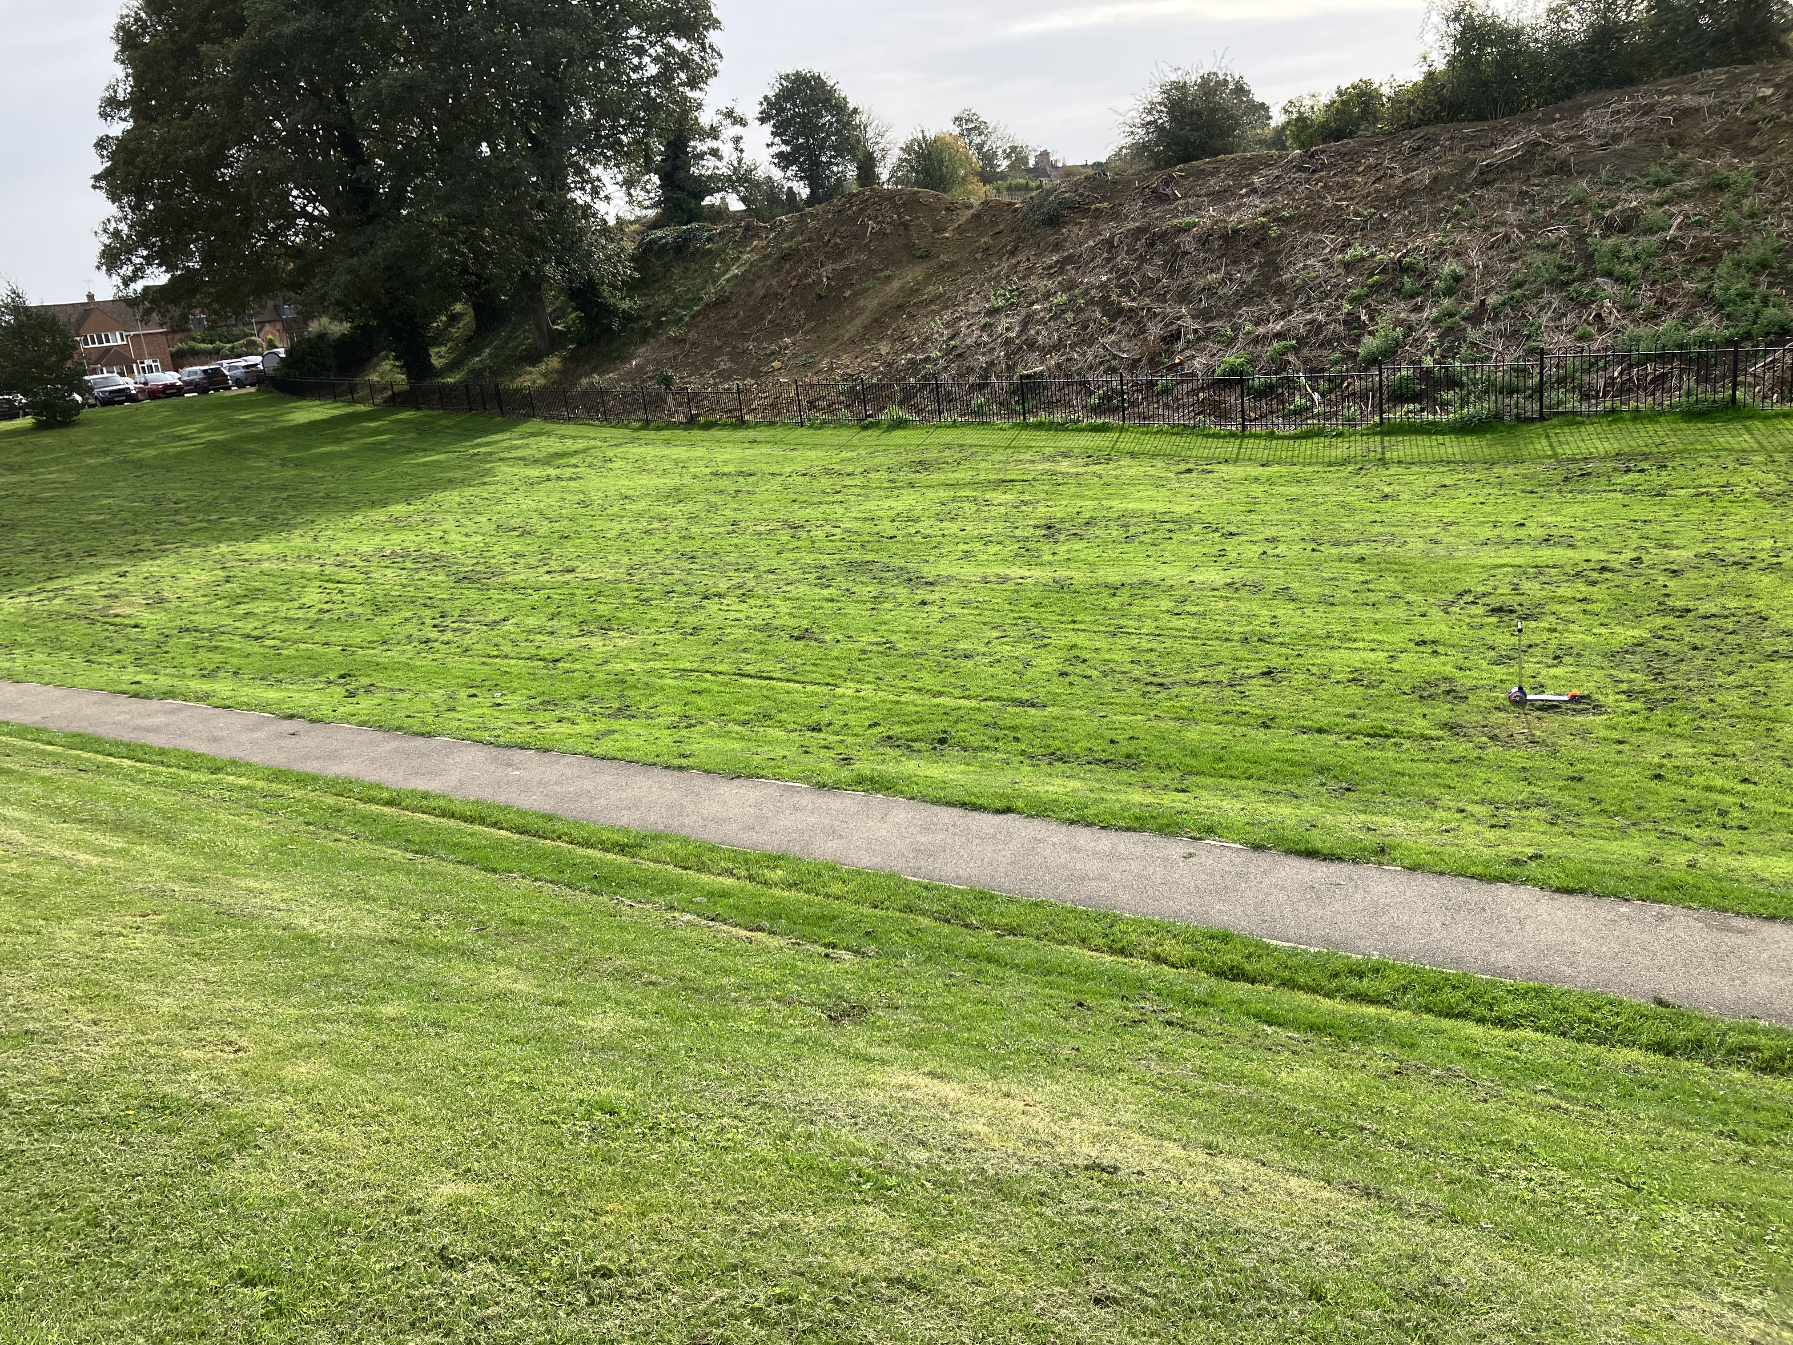

To illustrate even at the highest frequency of mowing not always perfect at Cutts Close. (07/10/23).

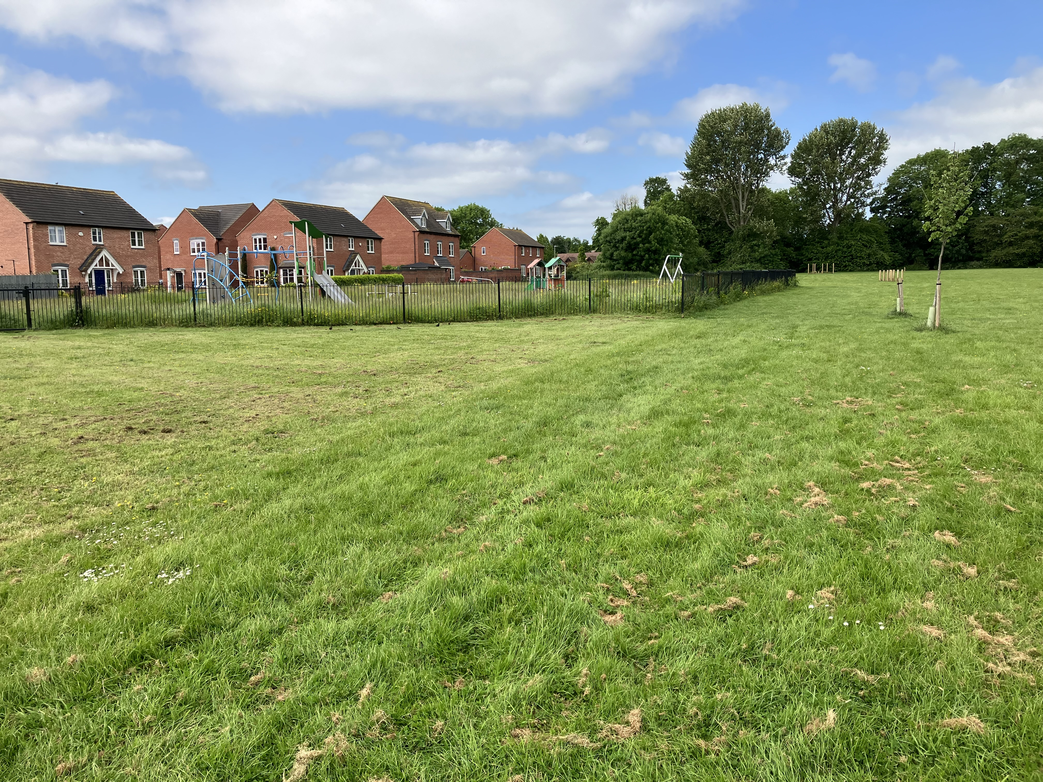

Capturing the confluence of 3 mowing contracts at Centenary Field (02/06/23). RCC play area behind fence. Mowing around detention pond to the left by Greenbelt. OTC on the right showing even after a substantial period of regrowth evidence of clods from the prior mow remain. (Our trim trail can be seen in the top right.)
Centenary Field at many times has looked more like cattle grazing area than a functional recreational asset.

Assumed areas of our open spaces were built-up as follows, 18,000 sq metres each for Cutts Close, Royce’s Recreation ground and Centenary Field, and a combined 15,000 square metres for All Saints and Willow Crescent. Cutts Close is oft quoted at 5 acres (see 2.1 in management plan) which would equal some 2 hectares (20,000 square metres), but from this, the areas of the bandstand, shelter, skatepark, paths etc would need removal to give a contracted area to cut. Centenary Field is linked to Fields in Trust, where https://www.fieldsintrust.org/FieldSite/Rutland-Remembers gives an area of 1.97ha. From this the area of the mature trees along Huntsmans Drive require deduction.

