Report: 13 | Council  Date of Meeting: 13th December 2023

OAKHAM TOWN COUNCIL

Report Author:  Phil Wildbore | Title:  Tree Champion
Subject: Tree Guards
Applicable Strategies:
- To protect and enhance amenities in Oakham Town.
- To preserve and enhance the rural, built, and natural environments of Oakham Town.
- To enable residents to be involved in the life of Oakham Town and its future development.

As well as wishing to improve numerical and statistical tree planting numbers, an overriding objective must be to enable their survival, otherwise 100% of any investment – time, labour, budget, gifting – is lost.
The November 2023 planting of 18 trees in Centenary Field potentially illustrated how the immediate protection of newly planted tree stock should be provided. This was delivered by George Walker through RCC.

There are 24 entries for ‘trees’ in our 2021-2023 Grounds Maintenance contract with Biffa, with one extract being at 2.3c:
‘Any irretrievable damage to any tree, shrub or other plants occurring accidentally, through malpractice or as a result of the Contractor failing to take adequate precautions shall result in the plant being replaced by the Contractor at his own expense with a plant of similar type, size and specification as agreed, with the Supervising Officer.’

To achieve preferential prices for future grounds maintenance contracts we need to ensure new plantings are protected to a good standard and facilitate their maintenance activities. If the bidders see high levels of risk on our estate, potential enforcement of the above clause will result in us paying higher rates for grounds maintenance.

Our current Grounds Maintenance specification/contract doesn’t include our requirement for suitable protection of trees (or shrubs.)

Proposal
- The new grounds maintenance contract must include a form of words, such as:
‘All newly planted trees must be protected from the day of installation. This should take the form of a minimum of two substantial (60-75mm diameter) stakes buried to a depth of at least 60 cm in the soil beyond the bottom of the tree planting hole. The above-ground portion of the stakes should reach no more than 2/3 of the way up the stem. Expandable straps are to be attached to each stake and the tree, making sure that the stakes cannot injure the tree.
Welded wire tree guards are to be provided at ground level and securely attached to each steak so as to prevent stem damage from maintenance activities like mowing.’
APPENDICES

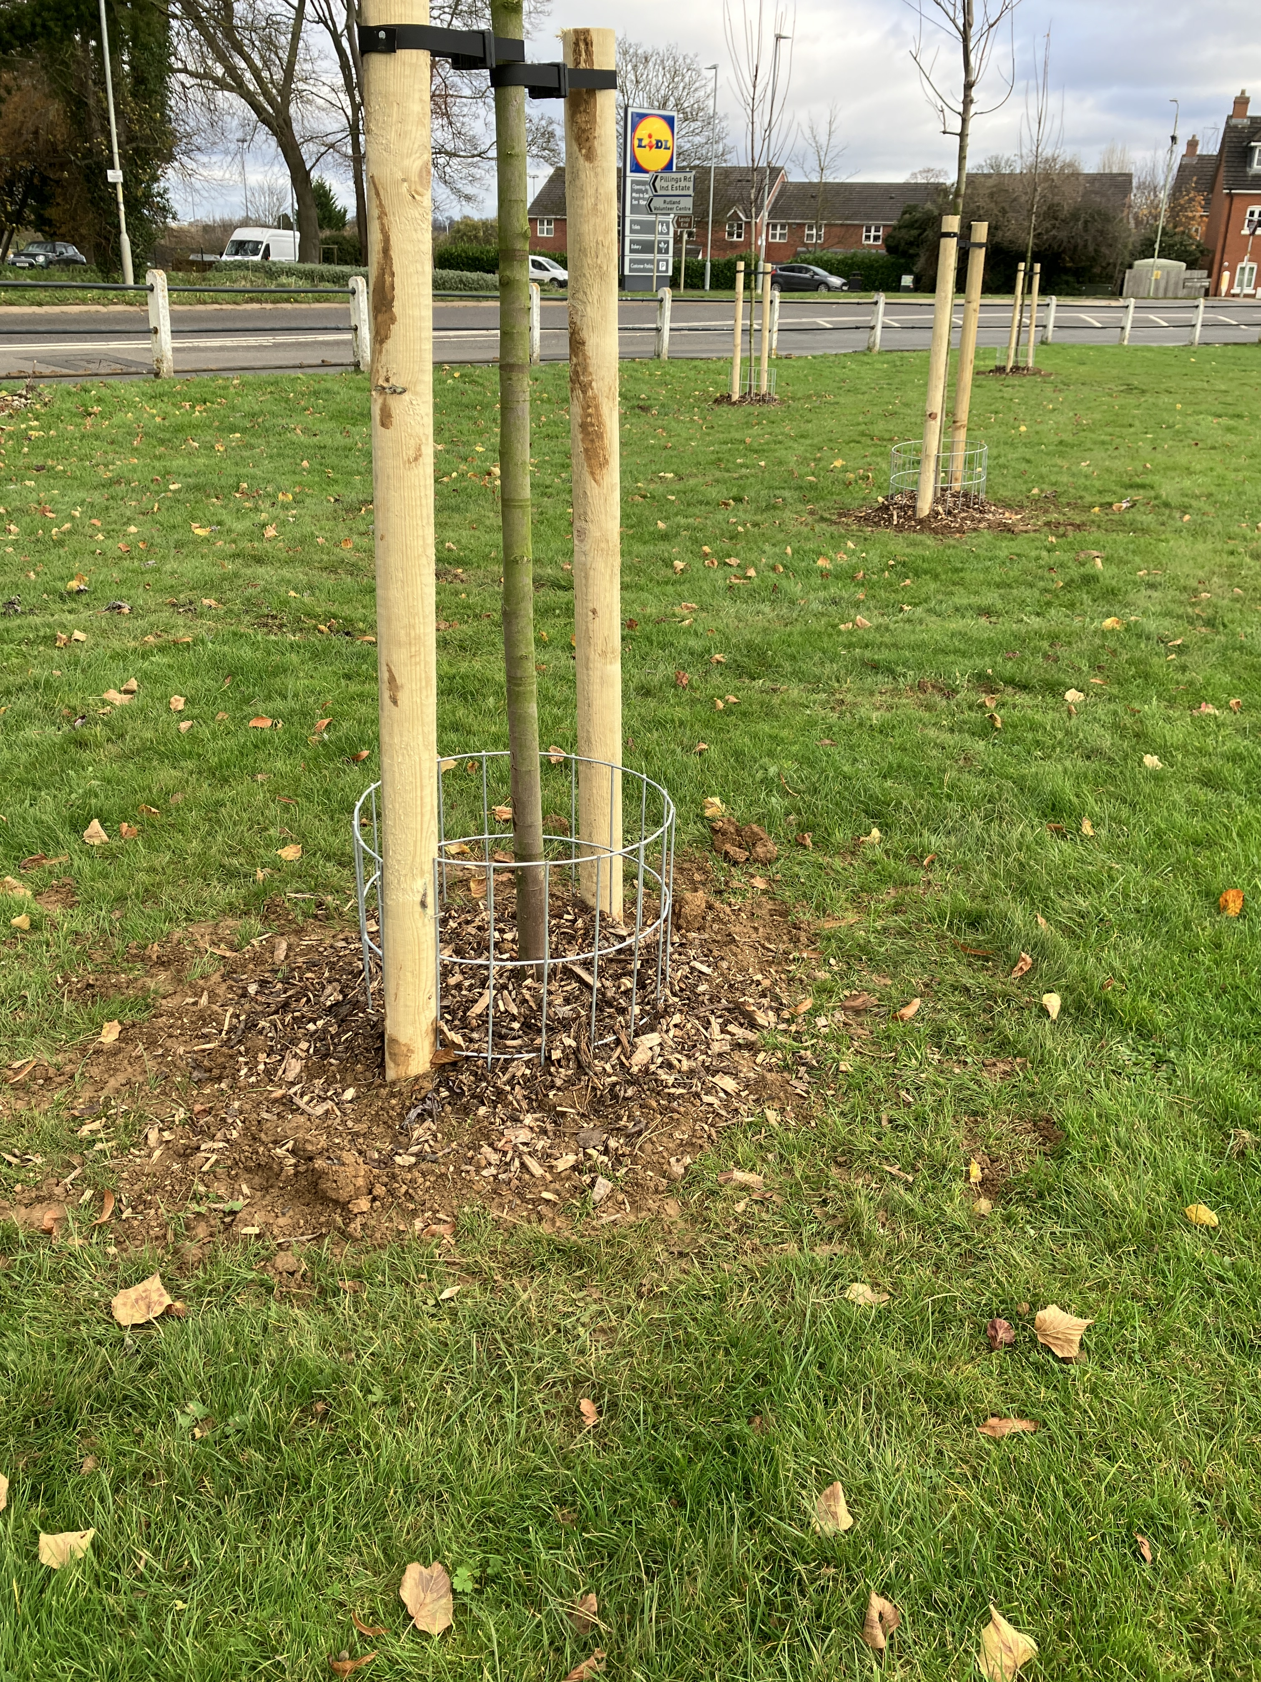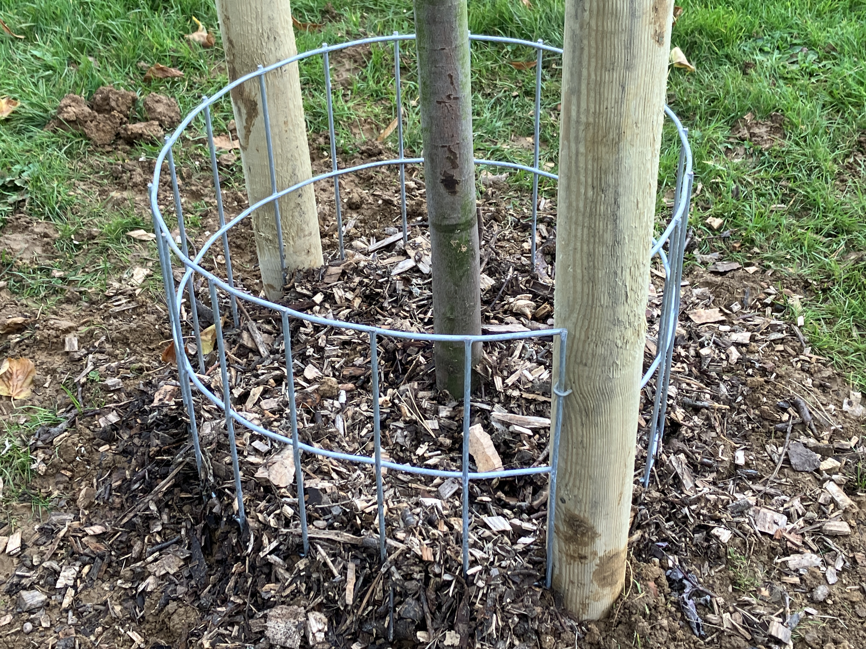

As intalled at 18 trees in Centenary Field 16 November 2023

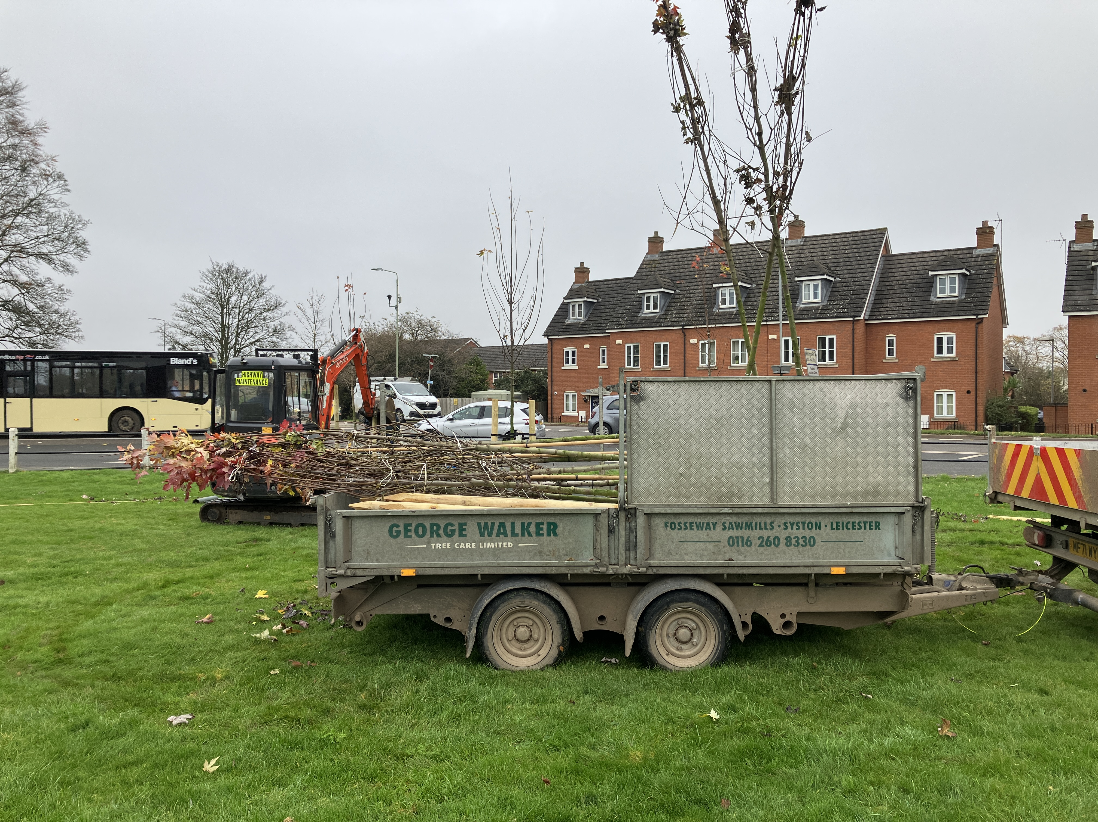

By having ‘a standard for Oakham Town Council’ in respect of new tree planting may encourage more cost-free installations.

Between 25% and 33% of newly planted trees die when installed by Local Authorities.
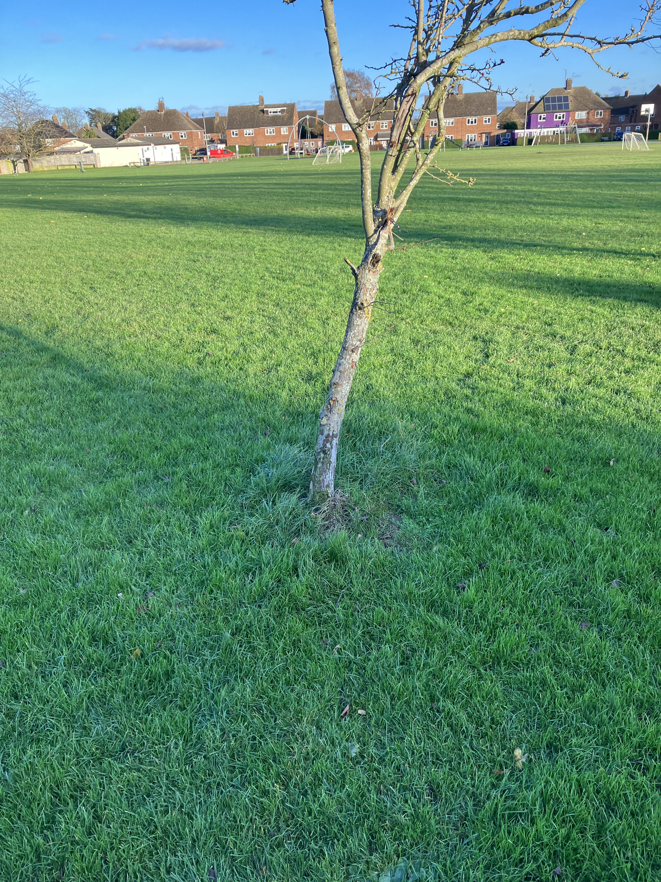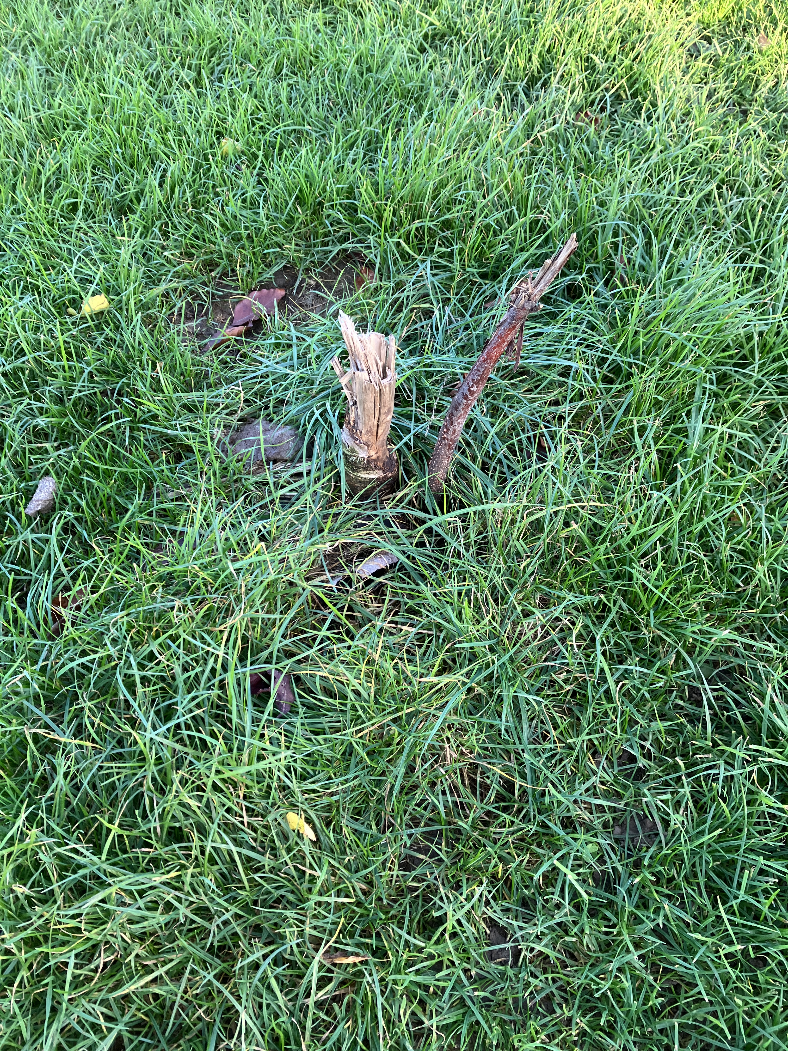

Royce’s Recreation Ground 24 November 2023 – no protection and demise.

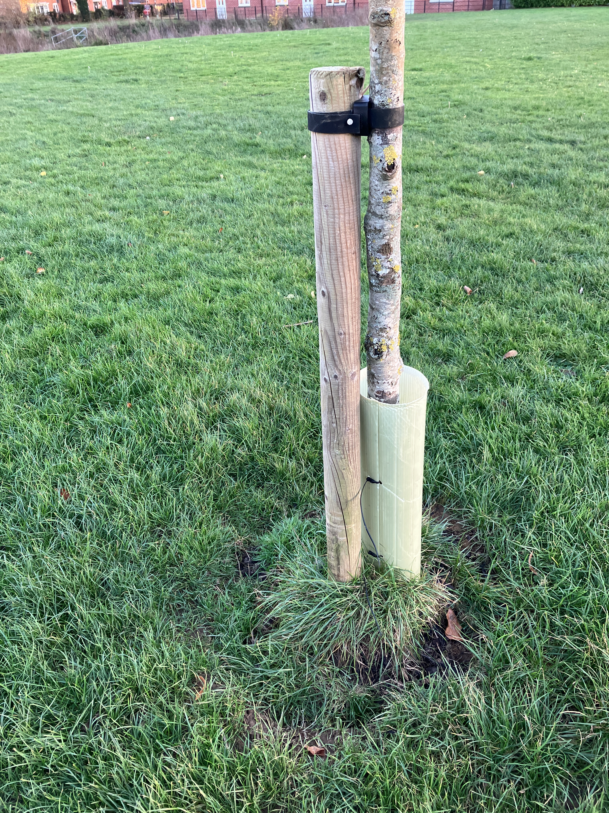

Typical minimal level of protection.

Clause 3.3a in current Grounds Maintenance contract:
‘The Contractor will cut as close as possible to any fixed obstruction i.e. trees, shrubs, signs, play equipment, outdoor furniture, inspection covers etc. Where due to obstructions the Contractor is not able to mow the full area specified by the defined machine method then the remaining area(s) shall be cut by other means to the same standard and frequency as the main area of which it forms part and on the same day.’

