|  |  |
| --- | --- |
| **Report No.**  **Appendix:**  **Agenda Item:** | **Council**  **Date of Meeting: 22nd February 2023** |

|  |
| --- |
| **OAKHAM TOWN COUNCIL** |

|  |  |
| --- | --- |
| **Report Authors: Cllr Sally-Anne Wadsworth** | **Title: Purchase of a New Bin** |
| **Subject Bins in Oakham** | |
| **Strategic Aims: To maintain the look of our community.**  **Bin on the bypass in Oakham just past Heron Road is damaged & needs replacing.** | |

The polythene unit, this costs in the region of £380 per bin to purchase and install.

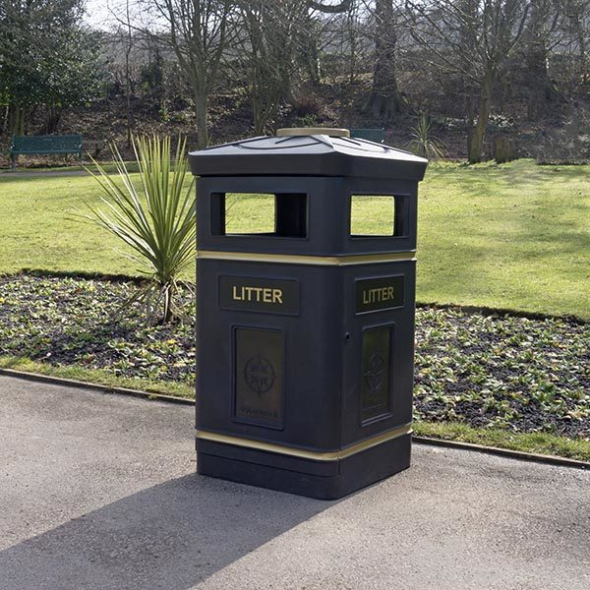

The Glass Fibre Composite Unit, this bin costs in the region of £560 to purchase and install.

