Paper 2022/32 8.3

Trees: Research and Meeting with Stuart Kidd on 28.11.22 to discuss planting replacement trees

Background:
- Trees are to replace those previously removed (to satisfy Forestry Commission in particular)
- Suggestion is to propose two locations, due to potential difficulty with planting at Cutts Close
- No specific budget already agreed, this will depend on our proposal for trees
- Tree planting should be done between Oct - Mar

Headline points:
- Suggestion of Option A: Cutts Close, Option B: Centenary Fields
- Agreement will need to be given by Forestry Commission & English Heritage, before

At the meeting with Stuart Kidd, there was a discussion about suitable sites, suitable trees and the process for tree planting. Please see some expanded points below:

Points on suitable sites:
- Cutts Close - expect this to be challenging due to restrictions, together with previous examples of difficulty with recent tree planted (took multiple years), and rejection of previous proposal to replace shelter.
(English Heritage in particular may object due to the historical significance/ potential for disturbing archeological remains)
Cutts Close is a ‘scheduled monument’ on the Historic England register: https://historicengland.org.uk/listing/the-list/list-entry/1010702?section=official-list-entry
Details of the forms and process are here: https://historicengland.org.uk/advice/planning/consents/smc/
Best location would be where young trees have recently been planted (see map below), close to steps up to Castle - between carpark and skate park; this would also be expected to provide much needed shade and shelter through hot summer months, without significant impact on existing vistas or views of the castle.
- Centenary Fields - site has connection to both Oakham Town Council and Rutland County Council, which may be seen as a positive for this project. Additional trees would be expected to add significant landscape value to this space, with little detrimental impact to current usage.
- Willow Crescent - not as public, so less value in replacement of public trees. Primary use is for allotments, rather than public recreation.
- Royce Park - less public than Cutts Close and Centenary Fields. Currently used by the public for recreation, including football which requires open space.
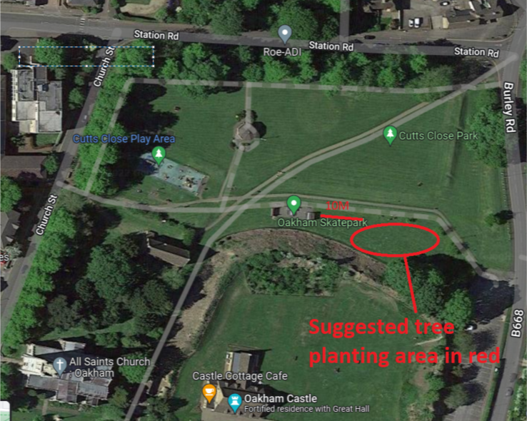

Points on selecting suitable trees from Stuart Kidd (Cllr Williams seeking additional list to support with decision making process):
- Suggested: common whitebeams, field maples and small-leaved lime trees.
- Rather than focus on native vs non-native, Stuart Kidd was keen to emphasise the importance of selecting trees for the desired qualities, i.e. biodiversity, shade, impact on landscape, reduction of flood risk etc.
- Smaller / younger trees establish quicker and better, but where vandalism risk is high then slightly larger/ more established trees may be more suitable.
- Rutland has alkaline soil
- Limes do particularly well
- Rowan doesn’t do so well
- English Oak doesn’t cope so well in drought (especially younger/ newly-planted trees)
- Rutland already has lots of Oak trees, and therefore this isn’t a recommended species due to increased risk of significant loss when species-specific disease hits (this is a matter of when, rather than if)

Expected process:
- Oakham Town Council agree (in principle) two options for location, and preferred tree species for planting (tree species could be subject to change - based on final location, tree supply, cost etc.)
- Confirm option A and option B location, and preferred tree species, to Stuark Kidd by email.
- Stuart Kidd will draw up plan with visual depiction of potential location of new trees, and send to Rob Clayton (RCC-Tourism/ Oakham Castle)
- Rob Clayton contacts Forestry Commission & Heritage England, seeking permission
- Timescale for response in unknown, but following permission being granted, budget and purchase of trees will be organised by RCC

Recommendations:
- Option A: Cutts Close, site as illustrated on map above
- Option B: Centenary Fields, planting location TBC
- Tree Species to be selected by a temporary tree working group, with delegated permission from Full Council.

