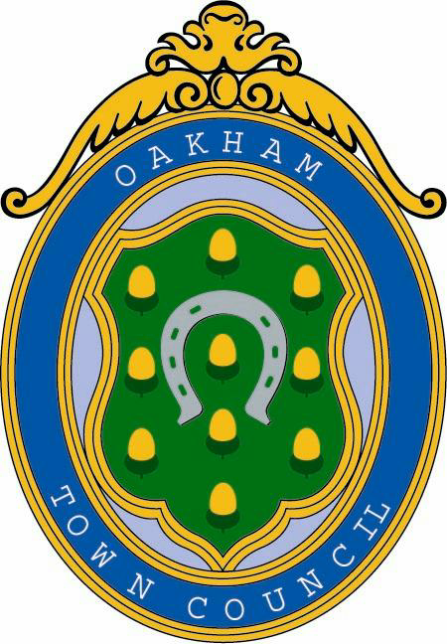

GRANT APPLICATION FORM

For Applications for the Financial Year
April 1st 2022 – March 31st 2023

Part 1: Your Details

Your Name:
Monica Compton

Name of Organisation:
All Saints Church- Oakham

Telephone: 07712 648828
E-Mail: fundraising@oakhamteam.org.uk

Address:
All Saints Church
Church Street
Oakham
LE15 6AA

If you are applying on behalf of a community or voluntary group, please give its name and address

PCC with Oakham All Saints- I am the grant coordinator

Part 2: A Description of your idea

All Saints Church is a grade 1 listed building with ten windows in need of urgent repair, some of which date back to 14th and 15th centuries. Below identifies the areas in need of work as identified in the 2018 Quinquennial report.

North Nave Aisle
In three bays to the west of the north transept. Central bay has a tall five-light window and ashlar masonry. The west and east bays are in coursed rubble stone. The parapet has a delicate string course below. Gargoyles and two redecorated aluminium downpipes. Masonry is stained, and the window mullions and tracery are particularly black. Glazing nearing the end of its useful life, but 2 central lights renewed. Re-lead within the quinquennium, in clear glass to bring more light into the church.

North Transept, West Wall
Coursed rubble stone beneath an ashlar parapet with ashlar buttresses and plinths. Repointed at higher level, the rubble stone is flaking, and much superficial mortar is falling off. Three-light window with bulging glazing nearing the end of its life should be re-leaded. Stonework in fair condition. Loose masonry capping by dry area should be fixed.

North Transept, North Wall
Two bays in coursed rubble stone with ashlar parapet, buttresses and dressings. Some minor cracking beneath the parapet with vertical movement joints in a section of stone wall which has obviously been raised, all repointed within last 10 years. Parapet is probably 19th century and the carvings on the string course are an imitation of the Medieval work. Two three-light windows with blackened stonework and 19th century glazing at the end of its useful life should be releaded. One light in eastern window renewed.

North Transept, East Wall
Coursed rubble stone with ashlar parapet, buttresses and plinth. Some movement in the rubble stone and bulging but this is all very much in the past. A three-light window with some renewed glazing. The rest of this window should to be re-glazed. Stonework in fair condition.

Trinity Chapel, North Wall
Four bays, ashlar masonry, in reasonable condition with moss growth on the buttresses. Parapet with plain string course. Four three-light windows, all with the same 19th century glazing (some renewals), reaching the end of its life, with some buckling. Two broken quarries in W window. All should be re-leaded. Stonework of the mullions and tracery blackened, and ventilating lights, probably in need of an overhaul.

West Wall of South Aisle
Small pieced masonry and rubble stone with substantial ashlar stonework to the plinth and to the parapet and just below the parapet. Much rich carving in the string course and the buttress caps and the pinnacle at the corner. All in reasonable condition, although some minor cracking evident around parapets on external wall side. Some repointing would be beneficial. Three-light window with nineteenth century glazing in fair condition and ventilating light in need of overhaul.

Please refer to attached brochure that further describes the window restoration.

Part 3: Your Community

Who would benefit from your project?

The repair of the windows will enable a safe environment within the church to continue to provide a place of worship and community support.

The church is open from roughly 8.30am-4/5pm, 365 days a year. On Sundays we have three services, with a combined attendance of around 160, plus five midweek services at which attendances are small but regular. During a four-week period we would generally have 32 regular services, and 2-3 funerals. We had 3 weddings in 2021 and in 2022 there have already been 3. We are significant
civic church, hosting Jubilee and Remembrance services and in 2022 the Memorial Service for the late Queen Elizabeth and in 2021 the late Duke of Edinburgh. Local schools hold their carol and end of term services here, and classes also visit to find out more about the history of the building and activities. Every two years we host the Justice Service, with a procession of judges to
the local court in Oakham Castle, and the Lord Lieutenant has recently held a service to thank local military, emergency services and volunteers for their service during the pandemic. We have also hosted hustings during General Election campaigns. Activities which take place in the church include bellringing, a choir, a small art/craft group, flower arrangers, church cleaners and meetings of the Parish Parochial Council and its subgroups. There is a flourishing Tiny Tots group which is run by church members but open to all and is greatly valued by the parents and grandparents. Pre-pandemic we have had tea parties for people living alone, a small ecumenical discussion group and meetings of the Oakham Christian Meditation Groups in church. All Saints has an active musical life, with weekly lunchtime concerts which give local musicians opportunities to perform, including students from Oakham School, local state schools and, during the school holidays, amateur and professional musicians. Rutland Choral Society, Corby Male Voice Choir and the and the Rutland Big Band have all held concerts here over the past year, and before the pandemic we had the Christmas Celebration organised by the NSPCC.

What difference will your project make?

The risk of not proceeding with this project is damage to the windows resulting in an unsafe building with overall outcome of the inability to provide worship and community support.

Part 4: Monitoring

How will you monitor the project once it has started?

Stephanie Norris, architect is overseeing the work.
The PCC are overall responsible for decision making.

Part 5: Funding

What is the total cost of your project? (Please remember to enclose two quotes if applicable)
The work has been awarded to Herringbone’s and attached is the total cost, when payments are due and what money has been secured

£95,702.85

How much money are you applying for?

£ 10,000

Have you applied for funding from anywhere else? Please give details

Benefact trust- awarded £2500
Rutland Historical Churches- awarded £8000
Oakham Memorial Trust – awarded £10000
Waiting for outcome with National Churches Trust

Please give an approximate breakdown, if applicable, of how you expect to spend the money:

Attached is the breakdown on the payments
Attached is the Herrinbone’s tender

If your application is unsuccessful, are funds available to ensure your project goes ahead? If yes, please give details:

Attached is the breakdown on the payments and money received.

Signature:_ 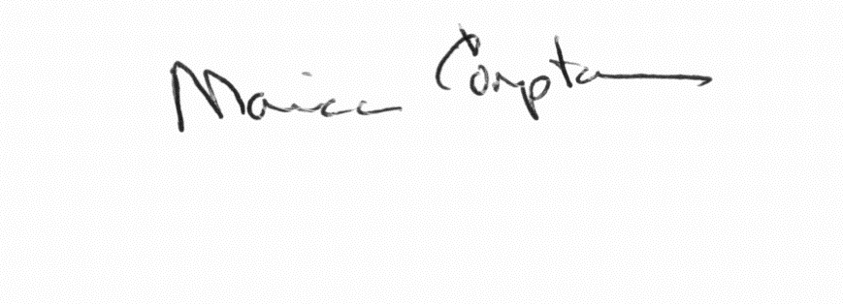 Date: 7th November 2022

Note: Please remember to supply the most recent set of accounts, if applicable, of your organisation.

Please return this form to: Town Clerk
Oakham Town Council
ROL House
Long Row
Oakham
Rutland
LE15 6LN

