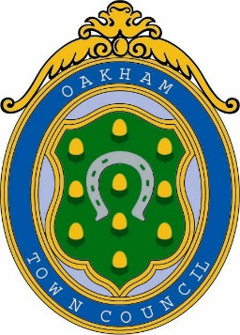
Oakham Town Council
Rol House, Long Row, Oakham, Rutland, LE15 6LN
01572 723627
enquiries@oakhamtowncouncil.gov.uk
www.oakhamtowncouncil.gov.uk

POST TITLE: General and Grounds Maintenance Person

HOURS: 15 hours per week

PURPOSE OF JOB: Principally, and in conjunction with others, to maintain the Town Council’s outside areas for the benefit of the residents of the Town.

PLACE OF WORK: Oakham

REPORTS TO: The Clerk

DUTIES AND RESPONSIBILITIES

1. Grass cutting of open spaces, play parks and verges.

2. Planting and maintaining the flower and shrub borders including pruning.

3. To assist in the maintenance and repair of public seats, shelters fences, notice boards and signs, reporting any major repair that may be required.

4. To regularly inspect, record and routinely maintain all play equipment and safety surfaces to ensure that the equipment is safe and fit for use. To paint with specified safety paint the play equipment as required and to report any defective equipment and prevent its further use until full repairs can be made.

5. To ensure the clearance of litter, weeds etc. from play areas, recreation grounds, open spaces, and the Town centre

6. To keep designated footpaths/tracks free of litter and vegetation.

7. Leaf clearance.

8. Weekend working as required to support Town Centre events. This will be predominantly in the summer months and either be paid at an enhanced rate or Time offered in Lieu

9. Under the health and safety guidelines issued by the Town Council, ensure the safety and well-being of all who visit or work in the facilities provided by the Council.

10. Adhere at all time to the policies and instructions of the Town Council.

The job activities quoted above are examples of the work involved. They do not purport to be a comprehensive list of all aspects of the principal duties.
Therefore the postholder will be required to undertake any other duties that may be required appropriate. You are required to wear protective clothing where appropriate, all of which will be provided.

