Report No.  Appendix:  Agenda Item: | Council: Full Council  Date of Meeting: 13 July 2022
OAKHAM TOWN COUNCIL
Report Author: Cllr Adam Lowe | Title: BIN
Title: BIN - Broken Latch - swinging open
Applicable Strategy:
- Ensure that Oakham remains a viable and pleasant environment in which to live, work and play.
- Improve and increase facilities within the town.
- Maintain and improve OTC land and buildings for the benefit of the community.
- Promote the town as an attractive place to visit and stay.

The BIN near the railway crossing footbridge at the end of the West End of the High Street has a broken latch and could be dangerous and basically look a mess.

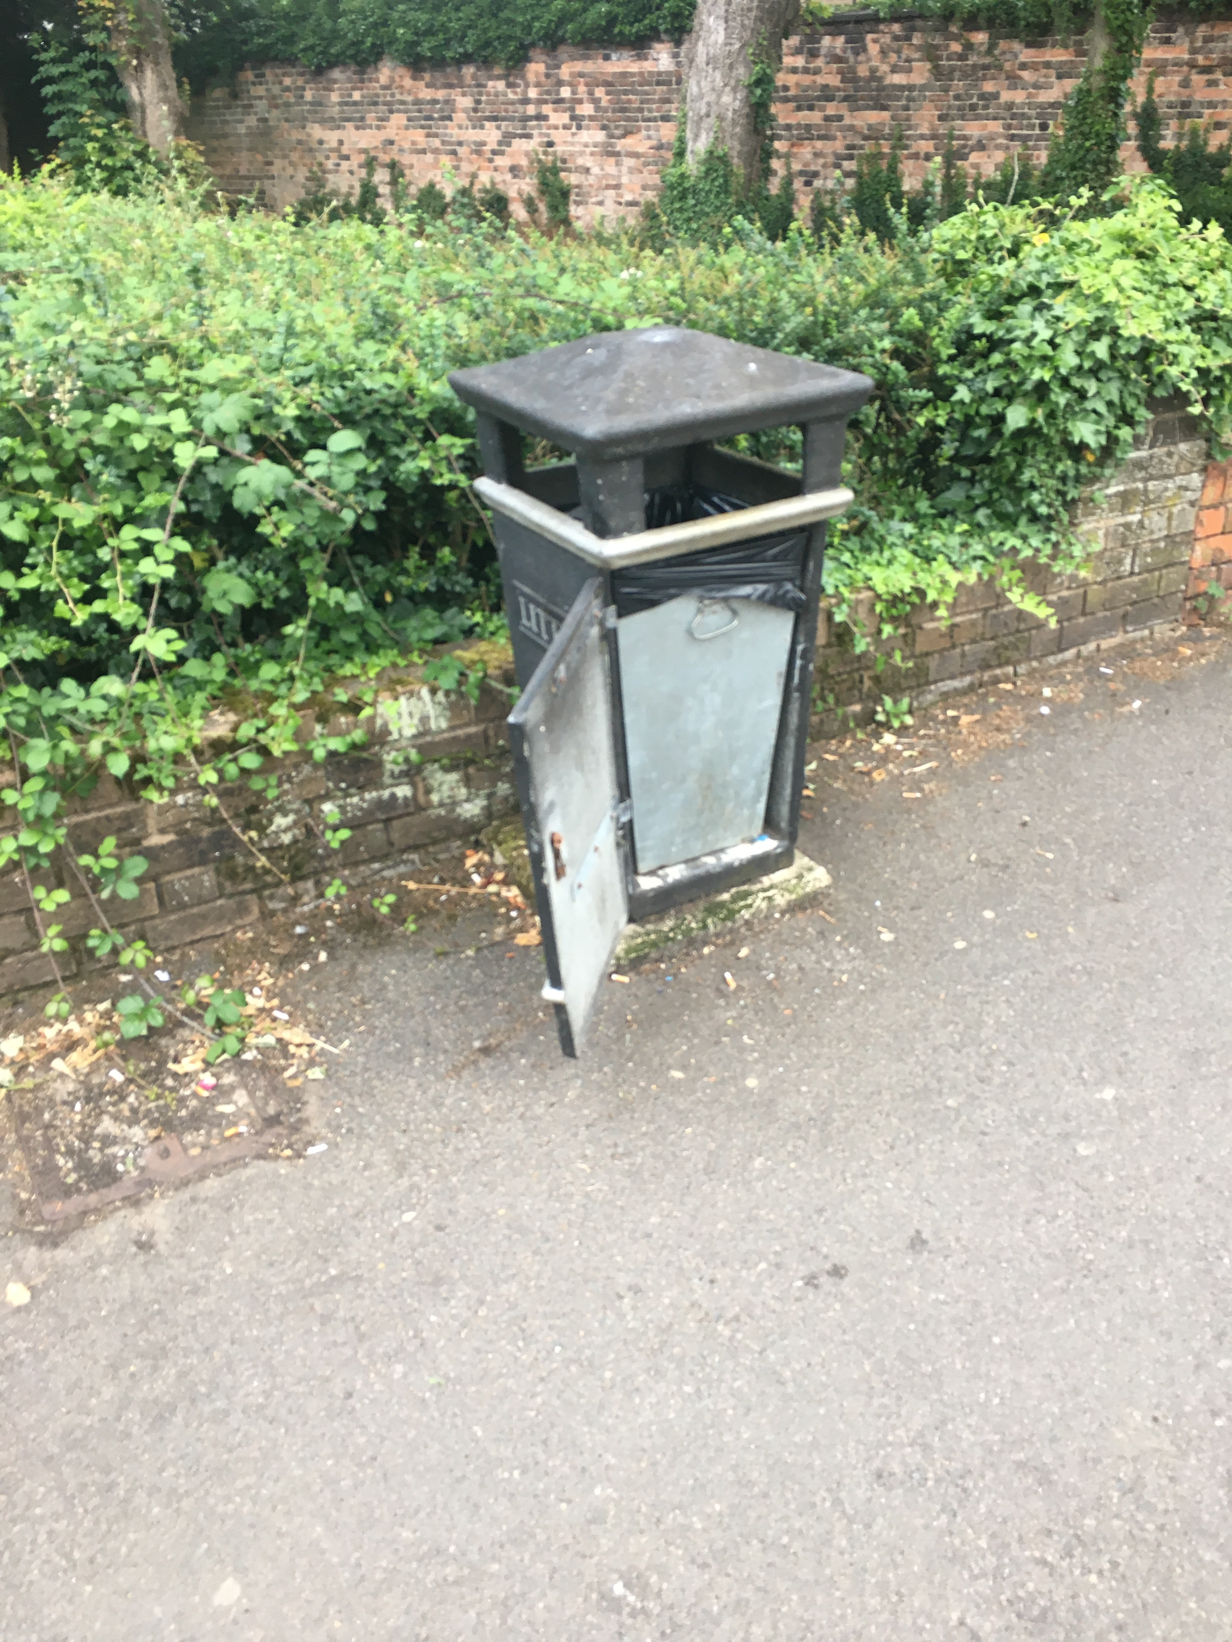
Would the Council consider requesting OTC to replace this bin with a new filly serviceable one. The Council may choose to complete a full bin audit and have a complete revamp and replace several bins as it believe there is a similar issue in Church passage.

- Council decide to replace one bin.
- Council decide to undertake a full survey and bring a more comprehensive paper back to Council in September 2022. With his onion the Council could delegate a Councillor and or the Office Staff ti undertake the comprehensive report.

