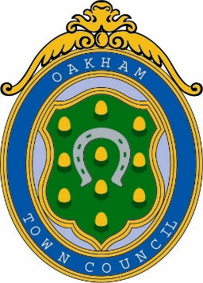

Oakham Town Council
Rol House, Long Row, Oakham, Rutland, LE15 6LN
01572 723627
enquiries@oakhamtowncouncil.gov.uk
www.oakhamtowncouncil.gov.uk

Calendar of Meetings for Council Year 2022-2023

All meetings are open to the public and commence at 6.30pm unless otherwise shown.
The Finance and Staffing Committee meetings are scheduled as required.

Date | Meeting
Wednesday 25th May 2022 | Recreation and Planning Committee
Wednesday 8th June 2022 | Council
Wednesday 29th June 2022 | Recreation and Planning Committee
Wednesday 13th July 2022 | Council
Wednesday 27th July 2022 | Recreation and Planning Committee
Wednesday 10th August 2022 | Council
Wednesday 7th September 2022 | Council
Wednesday 28th September 2022 | Recreation and Planning Committee
Wednesday 12th October 2022 | Council
Wednesday 26th October 2022 | Recreation and Planning Committee
Wednesday 9th November 2022 | Council
Wednesday 23rd November 2022 | Recreation and Planning Committee
Wednesday 7th December 2022 | Council
Wednesday 11th January 2023 | Council
Wednesday 25th January 2023 | Recreation and Planning Committee
Wednesday 8th February 2023 | Council
Wednesday 22nd February 2023 | Recreation and Planning Committee
Wednesday 8th March 2023 | Council
Wednesday 29th March 2023 | Recreation and Planning Committee
Wednesday 12th April 2023 | Council
Wednesday 26th April 2023 | Recreation and Planning Committee
Tuesday 9th May 2023 | 6pm Annual Town Meeting
Wednesday 10th May 2023 | Annual Meeting of the Council

