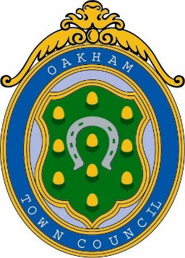
Oakham Town Council
Rol House, Long Row, Oakham, Rutland, LE15 6LN
01572 723627
enquiries@oakhamtowncouncil.gov.uk
www.oakhamtowncouncil.gov.uk

Press Release

Following the findings of the Rutland Council Conduct Committee on the 22nd March 2022
It was discussed at Oakham Town Council and agreed to accept the recommendations and issue a formal censure.

Cllr Lowe has therefore been removed as a member of all Committees and
appointments with the Council and this will remain in place until the 13th October 2022.

Any queries or questions regarding this decision can be directed to the Oakham Town Council Office.

Benjamin Tassell

Town Clerk

