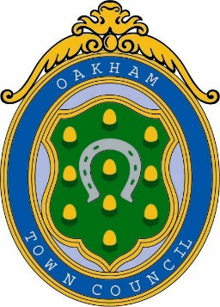
Oakham Town Council
Rol House, Long Row, Oakham, Rutland, LE15 6NL
01572 723627
enquiries@oakhamtowncouncil.gov.uk
www.oakhamtowncouncil.gov.uk
TO: All members of the Town Council
In accordance with the requirements of the Local government Act 1972, you are hereby summoned to attend a meeting of Oakham Town Councils Finance Committee on Wednesday 10 November 2021 at 6.30 p.m. The meeting will be held at the offices of the Town Council, Rol House, Long Row, Oakham, LE15 6LN immediately following a meeting of the full council which shall commence at 6.30 p.m.

Karen Bell
Karen Bell
Locum Clerk to the Council
03 November 2021
NOTICE OF MEETING
Public Notice of the meeting has been given in accordance with schedule 12, Para 10(2) of the Local Government Act 1972. The Meeting is open to the press and public. Members of the public attending this meeting are advised that it may be filmed and recorded.
AGENDA

APOLOGIES AND REASONS FOR ABSENCE: To receive and approve apologies for absences

- DECLARATION OF MEMBERS’ INTERESTS AND APPLICATIONS FOR DISPENSATION: Reminder to Members to disclose either a Pecuniary Interest or Other Interest in any item on the agenda. The clerk cannot advise members on this. Members are personally responsible for declaring an interest. Members are respectfully advised to read the Code of Conduct for more information. Councillors are also responsible for ensuring that their Registers of Interests are up to date (within 28 days of any changes)

- MINUTES FROM MEETING HELD ON 13 OCTOBER: To confirm the accuracy of the minutes (Previously circulated)
- 2021-2022 Review of Earmarked Reserves Policy Attached

- 2021-2022 Review of Earmarked Reserves Attached

- Risk Management Strategy: To consider Attached

- Investment Policy & Strategy: To Consider Attached

- 2022-2023 Draft Budget: To consider the Town Councils draft budgetary requirements as per the attached:
8.1 Draft Precept Budget Report
8.2 Draft Budget Document
8.3 Draft Budget
8.4 Notes to support the Draft Budget Calculations
8.5 2022-2023 Special Projects: To consider

- Date of Next Meeting: December 2021
Note: All meetings of the Parish Council & its committees are open to the press & public

