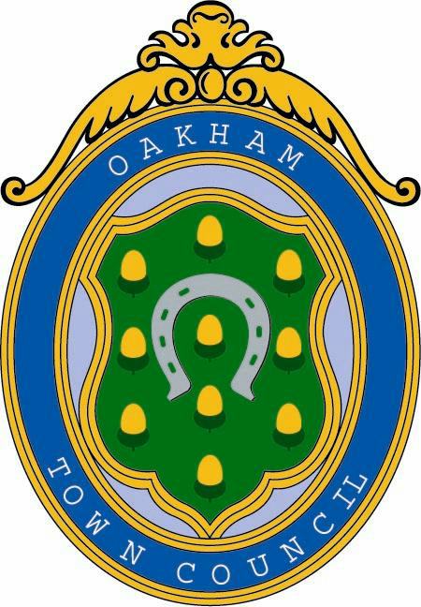

OAKHAM TOWN COUNCIL

STRATEGIC PLAN

Document Control
Version Number | 1
Adopted on | 20-03-19
Last Reviewed | 12-03-19
Review Date | 12-03-20

________________________________________________________________________

The Strategic Plan 2019-2025 1.1 Council Vision - the Vision of the Council: -
Oakham Town Council aims to improve the social and economic wellbeing of the community, and to protect the built environment of the town. It aims to work with other organisations and the community to provide efficient and high-quality services.
1.2 Oakham Town Council has a central role to play in developing and participating in all aspects of life in the town. It is a community leader, advocate and representative body comprised of residents elected to represent the community. Council Priorities
1.3 The priorities of the Council are: -
2.0 Democracy: the Town Council consists of an elected body of local people to provide a strong voice on decisions and services that affect the everyday life of local people including.
3.0 Community: The Town Council seeks to always be at the heart of the community and its activities. It will work closely with the many local voluntary, business, community groups and third/public sector partners within Oakham that are key to vibrant and successful community life.
4.0 Environment: Oakham has a strong identity and character due to its rich
natural and built heritage. The Town Council will work to ensure this heritage is protected and enhanced for present and future generations, including especially those buildings and areas of land for which it is custodian.
5.0 Economy: The Town Council will work actively with the business community and stakeholders to support the local economy and promote footfall also it will encourage good practice as an employer, landlord, steward of community assets and service provider.

________________________________________________________________________

2.0 Democracy
2.1 Representation – the Council will act as democratically elected leader of, and advocate for, the interests of the community with regard to service provision, infrastructure, wellbeing and community assets - working with the community and in partnership.
Councillors will receive support in their roles as representatives, leaders and the delivery of participation and engagement in public life.
2.2 General Power of Competence (GPC) – the Council will seek to maintain the GPC in order that it has the fullest opportunity to act for, and in the interests of, the residents of the town.
2.3 Consultation – the Council will seek to consult with electors before making changes that affect the populace or relevant stakeholder groups.
2.4 Civic/Ceremonial - the Council will seek to sustain civic and ceremonial traditions.

3.0 Community
3.1 Working together – the Council will work with the County Council and other representative bodies, partners and public authorities to promote a vibrant and healthy community life and wellbeing.
3.2 Communications - the Council will develop communications (including website, newsletter, social networking options) to meet statutory and other requirements, to communicate key messages.
3.3 Financial assistance - the Council will maintain a Grants Scheme to support eligible organisations providing benefits to the local community.
3.4 Outside Bodies - the Council will appoint representatives to, and work with, community and other groups supporting residents of the town.
3.5 Community Assets - the Council will manage the community assets in its ownership to support the development and delivery of community services, benefits and community wellbeing.
3.6 Allotments/burial grounds - the Council will maintain allotments and open spaces to serve the Parish, promoting health and community wellbeing.
3.7 Events – the Council will seek to deliver events which engage, entertain and/or inform the community and visitors whether on an annual or occasional basis.
3.8 Freedom of Entry - The Council will maintain strong relationship with the Military Community in recognition of their long-standing service to the County and Country.

________________________________________________________________________

4.0 Environment
4.1 Oakham has a strong identity and character due to its rich natural and built heritage. The Town Council will work to ensure this heritage is protected and enhanced for present and future generations, including especially those buildings and areas of land for which it is custodian.
4.2 Environment (general) - the Council will actively contribute to and promote policies and initiatives that support, protect and sensitively and sustainably develop the unique historic, built and natural environments of the town.
4.3 Environment (Council ownership) - the Council will maintain and protect the built heritage and natural assets in its ownership including through the maintenance of appropriate records, maintenance plans, inspections and works.
4.4 Trees - the Council will manage and maintain shrubs and trees on Council land including the maintenance of inspection, arboricultural and planting schemes.
4.5 Recreation – the Council will maintain existing play areas and, where appropriate, provide new areas for recreation as new developments and associated funding come forward.
4.6 New development – the Council will seek to inform and shape new development in the town to ensure sustainable and managed growth supported by appropriate infrastructure.

5.0 Economy
5.1 Economic Development – the Council will seek to support and/or deliver economic development initiatives to promote, develop and maintain a healthy local economy and commercial sector.
5.2 Working together – the Council will work with the Local Commerce, and other representative bodies, partners and public authorities to promote a vibrant and healthy local economy.
5.3 Best Value – the Council will work to minimise Council costs and provide value for money services which are relevant, efficient, economic and effective. In doing so it will reflect good employment and business practices.
5.4 Income generation – the Council will manage its commercial assets to provide income streams on an appropriate commercial basis to support the development and delivery of community services and benefits. The Council will also seek to develop new income streams which contribute to the local economy.

* * *

