Report No. TC00118  Appendix: E  Agenda Item No. 10 | Council  Date of Meeting: 10th January 2018
Oakham Town Council
Report Author: Cllr Adam Lowe | Title: Councillor
Subject: Tresham Land is registered as a WW1 Centenary Field,

Strategic Aim No. 1. Ensure that Oakham remains a viable and pleasant environment in which to live, work and play. 2. Improve and increase facilities within the town. 3. Maintain and improve OTC land and buildings for the benefit of the community. 4. Promote the town as an attractive place to visit and stay.

This came to Council some time ago and was pushed back for further details.
This follow up is a guide to costs.
The Tresham Land is under the Town Council responsibility on a long lease, the proposal does not remove that control and does not give up ownership of the Land in any way. The initiative in brief is that the Council identifies and registers the land as a Centenary Field for the benefit of Community, with a specific slant being that it is an area dedicated to commemoration of the Great War and an area that will in its current state continue to be an area for public with the emphasis being that it is a quiet area and an opportunity for reflection when it is used.
The indicative cost to the Council are purely around our Solicitor drawing up the paperwork in regard to the application and the Tresham Institute being made aware, as it is within the terms of our current agreement with them it actually will not impact that agreement.
A sign would be erected at a minimal cost, approx £200, to identify the land, the Council may choose to have an official unveiling should it choose to register the land.
Decision: The Council request the Clerk to the Council to complete the application to register the land as a Centenary Field and engage the Councils Solicitor at a cost not to exceed £1000. (indicative cost is between £300 and £600)

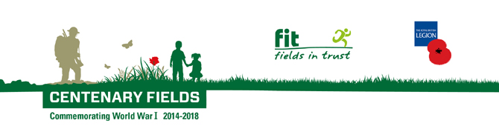

Background taken off the website.

Centenary Fields is working across the UK in partnership with The Royal British Legion to secure recreational spaces in perpetuity to honour the memory of the millions of people who lost their lives in World War I.
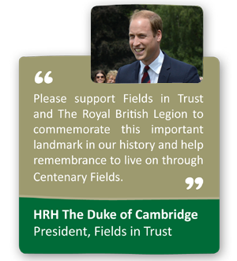

The Centenary Fields programme was launched in 2014 by Fields in Trust President HRH The Duke of Cambridge.

Delivered in partnership with The Royal British Legion, it is proving to be a unique way to commemorate the World War I centenary and remember those who lost their lives during the conflict, by protecting outdoor recreational space in perpetuity for the benefit of future generations.

Landowners across the UK are encouraged to dedicate a recreational space as a Centenary Field. Suitable spaces include war memorial playing fields and recreation grounds, memorial gardens, parks or recreation grounds that contain a war memorial and other valued green spaces that have some significance to WWI, either existing or planned.

By dedicating land through the Centenary Fields programme you can ensure your valuable green space is protected as a living remembrance to those who fought and lost their lives in World War I. At the same time your local community will be pleased that their local outdoor space is protected for future generations and will always be there. Dedicating a Centenary Field is also in keeping with the spirit of The Armed Forces Community Covenant.

